
OPC Unified Architecture
Release Candidate Specification
Part 6: Mappings
Version 0.93
June 1, 2006
Send comments to:
UAcomments@opcfoundation.org

Specification Type | Industry Standard Specification | Comments:
Title: | OPC Unified Architecture  Part 6  Mappings | Date: | June 1, 2006
Version: | Release Candidate 0.93 | Software | MS-Word
 |  | Source: | 0000.doc
Author: | OPC Foundation | Status: | Release Candidate

CONTENTS
Page
1 Scope 1
2 Reference Documents 1
3 Terms, definitions, and conventions 2
3.1 OPC UA Part 1 terms 2
3.2 OPC UA Part 2 terms 3
3.3 OPC UA Mappings terms 3
3.3.1 Communication Stack 3
3.3.2 Mapping 3
3.3.3 Encoding 3
3.3.4 Transport Protocol 4
3.3.5 Programmers' Interface 4
3.3.6 Certificate Store 4
3.3.7 Certificate Trust List 4
3.3.8 Certificate Revocation List 4
3.3.9 Certification Authority 4
3.4 Abbreviations and symbols 4
4 Overview 4
4.1 The Mapping Process 4
4.2 Communication Stacks 5
4.3 Message Encoding 5
4.4 Formal Interface Definition 5
4.5 Certificate Management 6
4.6 Server Discovery 6
5 Mappings 6
5.1 General 6
5.2 UA Native Mapping 6
5.2.1 General 6
5.2.2 Serialization Layer 8
5.2.3 Secure Channel Layer 9
5.2.4 Transport Layer 14
5.3 XML Web Services Mapping 19
5.3.1 General 19
5.3.2 SOAP 20
5.3.3 HTTP 21
5.3.4 WS Addressing 21
5.3.5 WS Security 22
5.3.6 WS Trust 23
5.3.7 WS Secure Conversation 23
6 Message Encoding 25
6.1.1 Built-in Types 25
6.2 UA Binary 26
6.2.1 General 26
6.2.2 Built-in Types 26
6.2.3 Enumerations 34
6.2.4 Arrays 34
6.2.5 Simple Types 34
6.2.6 Structures 34
6.2.7 Messages 35
6.3 XML 35
6.3.1 Built-in Types 35
6.3.2 Enumerations 41
6.3.3 Arrays 41
6.3.4 Structures 41
6.3.5 Messages 42
7 Formal Interface Definition 42
7.1 General 42
7.2 Mapping File 42
7.3 UA Native Mapping 42
7.4 XML Web Service Mapping 42
8 Managing Certificates 42
8.1 Certificate Stores 42
8.2 Application Instance Certificates 43
8.2.1 Installation 43
8.2.2 Certificate Trust Lists 43
8.2.3 Certificate Revocation Lists 43
8.2.4 Proof of Possession 43
8.3 Software Certificates 44
8.3.1 General 44
8.3.2 Verification 44
9 Server Discovery 44
9.1 Overview 44
9.2 WS-Inspection 44
9.3 WS-Discovery 45
9.4 UDDI 45
Annex A Constants 46
A.1 Service Type Ids 46
Annex B Type Declarations for the UA Native Mapping 47
Annex C WSDL for the UA XML Mapping 48
Annex D Mapping File Syntax 49
D.1 General 49
D.2 Dictionary 49
D.3 Abstract Type 50
D.4 Simple Type 50
D.5 Complex Type 51
D.6 Enumerated Type 52
D.7 Service Type 53

FIGURES
Figure 1 – The UA Native Mapping Stack Overview 7
Figure 2 – UA Native Mapping Message Processing 8
Figure 3 – Establishing a Secure Channel 11
Figure 4 – Renewing Security Tokens 12
Figure 5 – UA TCP Normal Message Sequences 15
Figure 6 – UA TCP Error Recovery Sequences 17
Figure 7 – The XML Web Services Stack 19
Figure 8 – Encoding Integers in a Binary Stream 27
Figure 9 – Encoding Floating Points in a Binary Stream 27
Figure 10 – Encoding Strings in a Binary Stream 28

TABLES
Table 1 – UA Native Mapping Message Header 8
Table 2 – UA Native Mapping Message Footer 9
Table 3 – Security Header Components 9
Table 4 – Security Footer Components 10
Table 5 – Security Algorithms 10
Table 6 – UA TCP Message Types 14
Table 7 – UA TCP Hello Message 16
Table 8 – UA TCP Acknowledge Message 16
Table 9 – UA TCP Disconnect Message 17
Table 10 – UA TCP Data Message 18
Table 11 – UA Abort Message 18
Table 12 – UA Error Message 18
Table 13 – WS-Addressing Headers 21
Table 14 – WS-Trust User Token Policy 23
Table 15 – WS-* Namespace Prefixes 23
Table 16 – ChannelSecurityToken to SCT Mapping 24
Table 17 – RequestSecurityToken Message Components 24
Table 18 – Security Algorithm Mappings 25
Table 19 – RequestSecurityTokenResponse Message Components 25
Table 20 – Built-in Data Types 26
Table 21 – Supported Floating Point Types 27
Table 22 – NodeId Components 29
Table 23 – NodeId Encoding Values 29
Table 24 – Two Byte NodeId Binary Encoding 29
Table 25 – Four Byte NodeId Binary Encoding 29
Table 26 – Uri NodeId Binary Encoding 30
Table 27 – Guid NodeId Binary Encoding 30
Table 28 – Standard NodeId Binary Encoding 30
Table 29 – DiagnosticInfo Binary Encoding 31
Table 30 – Extension Object Binary Encoding 32
Table 31 – Variant Binary Encoding 32
Table 32 – Variant Encoding Masks 33
Table 33 – Data Value Binary Encoding 33
Table 34 – Simple Type Mapping 34
Table 35 – Sample UA Binary Encoded Structure 35
Table 36 – XML Datatype Mappings for Integers 36
Table 37 – XML Datatype Mappings for Floating Points 36
Table 38 – String Format for Guid Components 37
Table 39 – Components of NodeId URI 38
Table 40 – Components of Enumeration 41
Table 41 – Certificate Store Locations 43
Table 42 – Dictionary Element Components 50
Table 43 – Abstract Type Element Components 50
Table 44 – Simple Type Components 51
Table 45 – Complex Type Components 52
Table 46 – Field Type Components 52
Table 47 – Enumerated Type Components 53
Table 48 – Service Type Components 54

OPC Foundation
____________

UNIFIED ARCHITECTURE –
FOREWORD
This specification is the specification for developers of OPC UA clients and servers. The specification is a result of an analysis and design process to develop a standard interface to facilitate the development of servers and clients by multiple vendors that shall inter-operate seamlessly together.
Trademarks
Most computer and software brand names have trademarks or registered trademarks. The individual trademarks have not been listed here.
NON-EXCLUSIVE LICENSE AGREEMENT
The OPC Foundation, a non-profit corporation (the “OPC Foundation”), has defined a set of standard objects, interfaces and behaviours associated with the objects intended to promote interoperability between automation/control applications, field systems/devices, and business/office applications in the process control industry.
The OPC specifications, sample software that demonstrates the implementation of the specifications, standard interface components deliverables and related documentation (collectively, the “OPC Materials”), form a set of standard objects, interfaces and behaviour that are based on the technology being used in the automation marketplace, and includes the use of Microsoft Technology as well providing interoperability to non Microsoft platforms. The technology defines standard objects, methods, and properties for servers of real-time information like distributed process systems, programmable logic controllers, smart field devices and analyzers in order to communicate the information that such servers contain to standard compliant technologies enabled devices (e.g., servers, applications, etc.).
The OPC Foundation will grant to you (the “User”), whether an individual or legal entity, a license to use, and provide User with a copy of, the current version of the OPC Materials so long as User abides by the terms contained in this Non-Exclusive License Agreement (“Agreement”). If User does not agree to the terms and conditions contained in this Agreement, the OPC Materials may not be used, and all copies (in all formats) of such materials in User’s possession must either be destroyed or returned to the OPC Foundation. By using the OPC Materials, User (including any employees and agents of User) agrees to be bound by the terms of this Agreement.
LICENSE GRANT:
Subject to the terms and conditions of this Agreement, the OPC Foundation hereby grants to User a non-exclusive, royalty-free, limited license to use, copy, display and distribute the OPC Materials in order to make, use, sell or otherwise distribute any products and/or product literature that are compliant with the standards included in the OPC Materials.
All copies of the OPC Materials made and/or distributed by User must include all copyright and other proprietary rights notices include on or in the copy of such materials provided to User by the OPC Foundation.
The OPC Foundation shall retain all right, title and interest (including, without limitation, the copyrights) in the OPC Materials, subject to the limited license granted to User under this Agreement.
WARRANTY AND LIABILITY DISCLAIMERS:
User acknowledges that the OPC Foundation has provided the OPC Materials for informational purposes only in order to help User understand Microsoft’s OLE/COM technology. THE OPC MATERIALS ARE PROVIDED “AS IS” WITHOUT WARRANTY OF ANY KIND, EXPRESS OR IMPLIED, INCLUDING, BUT NOT LIMITED TO, WARRANTIES OF PERFORMANCE, MERCHANTABILITY, FITNESS FOR A PARTICULAR PURPOSE OR NON-INFRINGEMENT. USER BEARS ALL RISK RELATING TO QUALITY, DESIGN, USE AND PERFORMANCE OF THE OPC MATERIALS. The OPC Foundation and its members do not warrant that the OPC Materials, their design or their use will meet User’s requirements, operate without interruption or be error free.
IN NO EVENT SHALL THE OPC FOUNDATION, ITS MEMBERS, OR ANY THIRD PARTY BE LIABLE FOR ANY COSTS, EXPENSES, LOSSES, DAMAGES (INCLUDING, BUT NOT LIMITED TO, DIRECT, INDIRECT, CONSEQUENTIAL, INCIDENTAL, SPECIAL OR PUNITIVE DAMAGES) OR INJURIES INCURRED BY USER OR ANY THIRD PARTY AS A RESULT OF THIS AGREEMENT OR ANY USE OF THE OPC MATERIALS.
GENERAL PROVISIONS:
This Agreement and User’s license to the OPC Materials shall be terminated (a) by User ceasing all use of the OPC Materials, (b) by User obtaining a superseding version of the OPC Materials, or (c) by the OPC Foundation, at its option, if User commits a material breach hereof. Upon any termination of this Agreement, User shall immediately cease all use of the OPC Materials, destroy all copies thereof then in its possession and take such other actions as the OPC Foundation may reasonably request to ensure that no copies of the OPC Materials licensed under this Agreement remain in its possession.
User shall not export or re-export the OPC Materials or any product produced directly by the use thereof to any person or destination that is not authorized to receive them under the export control laws and regulations of the United States.
The Software and Documentation are provided with Restricted Rights. Use, duplication or disclosure by the U.S. government is subject to restrictions as set forth in (a) this Agreement pursuant to DFARs 227.7202-3(a); (b) subparagraph (c)(1)(i) of the Rights in Technical Data and Computer Software clause at DFARs 252.227-7013; or (c) the Commercial Computer Software Restricted Rights clause at FAR 52.227-19 subdivision (c)(1) and (2), as applicable. Contractor / manufacturer are the OPC Foundation, 16101 N. 82nd Street, Suite 3B, Scottsdale, AZ, 85260-1830
Should any provision of this Agreement be held to be void, invalid, unenforceable or illegal by a court, the validity and enforceability of the other provisions shall not be affected thereby.
This Agreement shall be governed by and construed under the laws of the State of Minnesota, excluding its choice or law rules.
This Agreement embodies the entire understanding between the parties with respect to, and supersedes any prior understanding or agreement (oral or written) relating to, the OPC Materials.

Scope
This document specifies mapping between the security model described in [UA Part 2], the abstract service definitions described [UA Part 4] and the data structures defined in [UA Part 5] and the physical network protocols that can be used to implement the UA specification.

Reference Documents
[UA Part 1] OPC UA Specification: Part 1 – Concepts
http://www.opcfoundation.org/UA/Part1/
[UA Part 2] OPC UA Specification: Part 2 – Security Model
http://www.opcfoundation.org/UA/Part2/
[UA Part 3] OPC UA Specification: Part 3 – Address Space Model
http://www.opcfoundation.org/UA/Part3/
[UA Part 4] OPC UA Specification: Part 4 – Services
http://www.opcfoundation.org/UA/Part4/
[UA Part 5] OPC UA Specification: Part 5 – Information Model
http://www.opcfoundation.org/UA/Part5/
[UA Part 7] OPC UA Specification: Part 7 – Profiles
http://www.opcfoundation.org/UA/Part7/
[XML Schema Part 1] XML Schema Part 1: Structures
http://www.w3.org/TR/xmlschema-1/
[XML Schema Part 2] XML Schema Part 2: Datatypes
http://www.w3.org/TR/xmlschema-2/
[SOAP Part 1] SOAP Version 1.2 Part 1: Messaging Framework
http://www.w3.org/TR/soap12-part1/
[SOAP Part 2] SOAP Version 1.2 Part 2: Adjuncts
http://www.w3.org/TR/soap12-part2/
[XML Encryption] XML Encryption Syntax and Processing
http://www.w3.org/TR/xmlenc-core/
[XML Signature] XML-Signature Syntax and Processing
http://www.w3.org/TR/xmldsig-core/
[WS Security] SOAP Message Security 1.1
http://www.oasis-open.org/committees/download.php/16790/wss-v1.1-spec-os-SOAPMessageSecurity.pdf
[X509 Security Token Profile] X509 Security Token Profile
http://www.oasis-open.org/committees/download.php/16785/wss-v1.1-spec-os-x509TokenProfile.pdf
[WS Addressing] Web Services Addressing (WS-Addressing)
http://www.w3.org/Submission/ws-addressing/
[WS Trust] Web Services Trust Language (WS-Trust)
http://specs.xmlsoap.org/ws/2005/02/trust/WS-Trust.pdf
[WS Secure Conversation] Web Services Secure Conversation Language (WS-SecureConversation)
http://specs.xmlsoap.org/ws/2005/02/sc/WS-SecureConversation.pdf
[SSL/TLS] RFC 2246: The TLS Protocol Version 1.0
http://www.ietf.org/rfc/rfc2246.txt
[X509] X.509 Public Key Certificate Infrastructure
http://www.itu.int/rec/T-REC-X.509-200003-I/e
[WS-I Basic Profile 1.1] WS-I Basic Profile Version 1.1
http://www.ws-i.org/Profiles/BasicProfile-1.1.html
[WS-I Basic Security Profile 1.1] WS-I Basic Security Profile Version 1.1
http://www.ws-i.org/Profiles/BasicSecurityProfile-1.1.html
[HTTP] RFC 2616: Hypertext Transfer Protocol - HTTP/1.1
http://www.ietf.org/rfc/rfc2616.txt
[HTTPS] RFC 2818: HTTP Over TLS
http://www.ietf.org/rfc/rfc2818.txt
[Base64] RFC 3548: The Base16, Base32, and Base64 Data Encodings
http://www.ietf.org/rfc/rfc3548.txt
[X690] ITU-T X.690: Basic (BER), Canonical (CER) and Distinguished (DER) Encoding Rules
http://www.itu.int/ITU-T/studygroups/com17/languages/X.690-0207.pdf
[IEEE-754] Standard for Binary Floating-Point Arithmetic
http://grouper.ieee.org/groups/754/
[PKCS #12] PKCS #12: Personal Information Exchange Syntax Standard
http://www.rsasecurity.com/rsalabs/node.asp?id=2138
[HMAC] HMAC: Keyed-Hashing for Message Authentication
http://www.ietf.org/rfc/rfc2104.txt
[PKCS #1] PKCS #1: RSA Cryptography Specifications Version 2.0
http://www.ietf.org/rfc/rfc2437.txt

[FIPS 180-2] Secure Hash Standard (SHA)
http://csrc.nist.gov/publications/fips/fips180-2/fips180-2.pdf

[FIPS 197] Advanced Encyption Standard (AES)
http://www.csrc.nist.gov/publications/fips/fips197/fips-197.pdf
[WS Inspection] Web Services Inspection Language (WS-Inspection) 1.0
http://msdn.microsoft.com/library/en-us/dnglobspec/html/ws-inspection.asp

Terms, definitions, and conventions

OPC UA Part 1 terms
The following terms defined in [UA Part 1] apply.
- AddressSpace
- Attribute
- Certificate
- Message
- Node
- Profile

OPC UA Part 2 terms
The following terms defined in [UA Part 2] apply.
- OPC UA application
- Authentication
- Integrity
- Authorization
- X.509 Certificate
- SoftwareCertificate
- SessionKeySet
- SecurityToken
- SecureChannel
- PublicKey
- PrivateKey
- Nonce
- Application Certificate
- Software Certificate

OPC UA Mappings terms

Communication Stack
A Communication Stack is a collection of software libraries that implement one or more communication protocols. Communication Stacks usually have multiple layers where application specific higher level protocols build on more generic lower level protocols.

Mapping
A Mapping is way to implement UA using a specific Communication Stack. UA currently defines two mappingxs: the XML Web Services mapping and the UA Native mapping.
Mapping | Encoding | Transport Protocol
XML Web Services | UA Binary or XML | SOAP/HTTP
UA Native | UA Binary | SOAP/HTTP or UA TCP

Encoding
An Encoding is a format that can be used to serialize the UA messages and data structures. UA currently defines two encodingxs: XML and UA Binary.

Transport Protocol
A Transport Protocol is a way to exchange serialized UA messages between UA applications.

Programmers' Interface
A Programmers' Interface is a software interface that presents an abstract view of a Communication Stack and allows application developers to build applications without knowing the implementation details for the stack.

Certificate Store
A Certificate Store is a database that can securely store X509 Certificates, Certificate Revocation Lists and Certificate Trust Lists.

Certificate Trust List
A Certificate Trust List is a list of X509 certificates that are trusted by a UA application.

Certificate Revocation List
A Certificate Revocation List is a list of X509 certificates that have been revoked by a Certification Authority.

Certification Authority
A Certification Authority is an entity responsible for issuing X509 certificates.

Abbreviations and symbols
API Application Programming Interface
UA Unified Architecture
WS-* The XML Web Services Specifications.
BP WS-I Basic Profile Version
BSP WS-I Basic Security Profile
XML Extensible Markup Language
TCP Transmission Control Protocol
SOAP Simple Object Access Protocol
HTTP Hypertext Transfer Protocol
SHA1 Secure Hash Algorithm
SSL Secure Sockets Layer
TLS Transport Layer Security
WSS WS Security
WS-SC WS Secure Conversation
RST Request Security Token
RSTR Request Security Token Response
CRL Certificate Revocation List
CTL Certificate Trust List
CA Certificate Authority

Overview

The Mapping Process
The other parts of the UA specification are written to be independent of the technology used for implementation. This approach means UA is a flexible specification that will continue to be applicable as technology evolves. On the other hand, this approach means that it is not possible to build a UA application with the information contained in Parts 1 through 5 because important implementation details have been left out. This document addresses this problem by specifying exactly how the UA specification should be mapped to different implementation technologies.
This document defines two mappings at this time: XML Web Services and UA Native. The XML Web Services mapping specifies how UA applications may be implemented using SOAP and the various WS-* specifications. The UA Native mapping specifies how a UA application may be implemented using a simple binary network protocol such as TCP/IP.
Each of profiles defined in [UA Part 7] specifies one or more mappings which must be implemented by UA applications that support the profile.

Communication Stacks
Implementations of distributed applications like UA are built with software libraries that handle the transfer of data across the network using different network protocols. All of these libraries provide an application programmers' interface (API) that hides the details of the network protocol from the application programmer. In many cases, network protocols are layered on top of other network protocols in what is usually described as a communication stack.
UA makes a distinction between features that are implemented by the application and those which are implemented by the communication stack. Features that are implemented in the communication stack are features that have a common implementation for all UA applications. In many cases, application developers will not have to implement the features provided by the communication stack because standard 'off the shelf' implementations already exist for the development environment they plan to use.
Each UA mapping is based on a standard communication stack that provides a basic level of functionality. In some cases, additional UA specific capabilities must be added to the standard stack. This document does not specify how to implement these standard stacks but simply indicates what features are required and references the specifications that define the key components of these stacks.

Message Encoding
Messages are the basic unit of communication between UA applications. To send a message a UA application must serialize it as a sequence of bytes or characters so it can be sent across a network. The format of the serialized message is called an encoding.
The message encoding and decoding is done by the communication stack. Each mapping will specify the message encoding(s) that may be used as part of the mapping.
This document defines two encodings at this time: UA Binary and XML. The UA Binary encoding is a format that efficiently represents UA messages as binary data. The XML encoding is an XML representation of the same UA message.
Each of the profiles defined in [UA Part 7] specifies an encoding which must be used by UA applications that support the profile.

Formal Interface Definition
Each mapping must also have a formal definition that describes the format of each UA message exchanged between applications. For some mappings, the formal interface definition must also describe how the messages are exchanged.
This document describes process used to create the formal definitions from the abstract specification for each mapping. In addition, this document includes the complete interface definition for each mapping in an appendix.

Certificate Management
UA makes extensive use of digital certificates to provide security. Implementing UA requires a mechanism to create, distribute and control access to these certificates from within the UA applications. All UA mappings use the X509 format to create and distribute digital certificates.
This document describes how these certificates should be installed and the security issues that the application developer must consider.

Server Discovery
Before a UA client can connect to a UA server it must know the network address for the server. However, configuring each client with the address of each server in advance creates many administration problems. For that reason, UA requires a mechanism to publish UA services that are available on the network.
This document describes how different discovery services can be adapted for use with UA.

Mappings

General
This clause defines the OPC UA mappings. Clause 6 defines the message encodings that are used by the mappings. Clause 7 defines the formal interface contracts for each mapping.

UA Native Mapping

General
The UA native mapping defines a communication stack that is built on top of TCP/IP or similar low level network protocol. This stack consists of three key componentxs: a transport layer that manages a communication session over the underlying protocol, a secure channel layer that ensure privacy an integrity of messages by implementing the UA secure channel services and a serialization layer which encodes/decodes messages using the UA binary encoding.
An overview of the stack for the UA native mapping is shown in Figure 1.

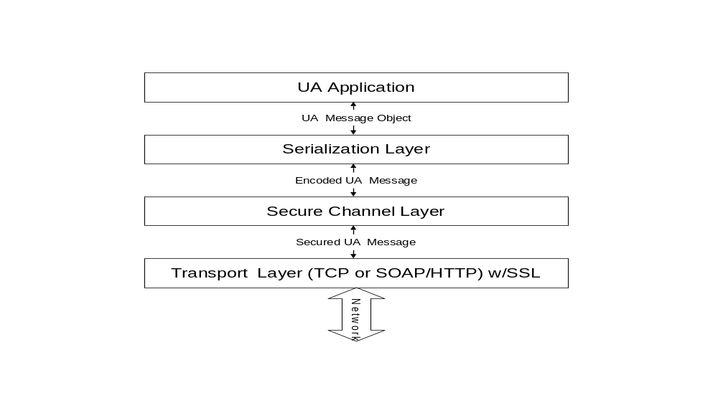
Figure 1 – The UA Native Mapping Stack Overview

illustrates how UA messages are processed as they pass through the different layers. The processing done by each layer is described in the sections follow.
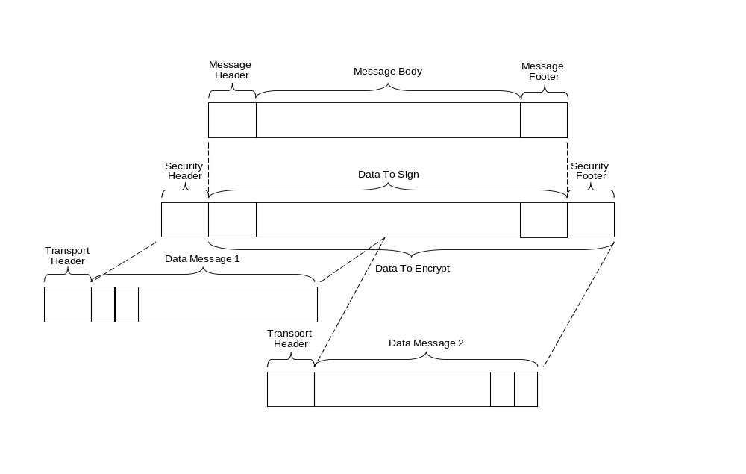
Figure 2 – UA Native Mapping Message Processing

Serialization Layer
The serialization layer uses the UA binary encoding (see Clause 6.2) to serialize/deserialize UA message structures that store the service parameters. The UA message structures themselves depend on the programming environment and are not defined as part of the mapping. For that reason, the serialization layer will have different implementations for different programming environments.
Each service message defined in [UA Part 4] has either a RequestHeader or a ResponseHeader. The UA native mapping extracts the SecurityHeader parameter from these headers and implements it in the secure channel layer (see Clause 5.2.3).

Table 1 – UA Native Mapping Message Header
Name | Type | Description
ServiceId | NodeId | The data type id for the message.  This is a NodeId encoded with a two or four-byte encoding (see Clause 6.2.2.10).
MessageLength | Int32 | The length of the message body in bytes.  The length does not include the length of the MessageFooter.  If the length is not known then this value is -1.

The serialization layer also adds a MessageFooter that contains the location of all ExtensionObjects in the message which were serialized without a length prefix. The structure of the MessageFooter is described in Table 2.
Table 2 – UA Native Mapping Message Footer
Name | Type | Description
ExtensionObjectPositions | ExtensionObjectPosition[] | A list of ExtensionObjects encoded in the body of the message without a length prefix.  This list must be ordered by StartPosition.
StartPosition | UInt32 | The number of bytes from the beginning of the message body to the first byte of the ExtensionObject body.
EndPosition | UInt32 | The number of bytes from the beginning of the message body to the first byte after the ExtensionObject body.  The difference between the StartPosition and EndPosition is the length of the ExtensionObject body.
MessageLength | UInt32 | The length of the message body.  The is also position of the start of the MessageFooter.

The decoder must use the MessageFooter when it encounters an ExtensionObject which does not have either a data type id that it recognizes or a length prefix. When this happens, the decoder must find the MessageLength in the header or jump to the end of the stream and read the MessageLength from the footer. The MessageLength tells the decoder where the list of ExtensionObjectPositions starts. The decoder then looks for a entry with a StartPosition that matches the position where the unknown ExtensionObject was encountered.
Decoders that cannot jump to the end of the message stream must return an error.
All messages always have a MessageFooter that is at least 8 bytes long (4 bytes to indicate an empty list and 4 bytes for the footer start position).
The MessageHeader and MessageFooter are encoded using the UA binary encoding.

Secure Channel Layer

General
The UA secure channel layer manages a virtual connection between two applications that ensures that all messages exchanged via the channel are secured (i.e. signed and/or encrypted). The secure channel connection is always tied to a single transport layer session.
The secure channel layer prepends a SecurityHeader to the encoded message that tells the receiver what security algorithms have been applied to the message. The components of the SecurityHeader are described in Table 3.
Table 3 – Security Header Components
Name | Type | Description
SigningToken | ByteString | The token used to sign the message.
SignatureMethod | String | The algorithm used to sign the message.  Not specified if the message is not signed.
EncryptingToken | ByteString | The token used to encrypt the message.
EncryptionMethod | ByteString | The algorithm used to encrypt the message.  Not specified if the message is not encrypted.

The SecurityHeader is encoded using the UA binary encoding. How each field is used is described in the clauses below
The secure channel layer must also append a SecurityFooter to the encoded message that provides additional information which the receiver needs to process and validate the message. The components of the SecurityFooter are shown in Table 4.
Table 4 – Security Footer Components
Name | Type | Description
Signature | ByteString | The signature calculated for the message.  The number of bytes depends on the signature algorithm.
Padding | ByteString | Empty bytes required make the message size (including the SecurityFooter) a multiple of the encryption algorithm block size.
Message Size | UInt32 | The size of the unencrypted message not including the SecurityHeader or SecurityFooter.

All encryption algorithms operate on a fixed block size which means is usually necessary to add padding to the end of a message fill up an encryption block. The Padding in the SecurityFooter exists for this purpose. The length of the padding can be calculated with the following formula:
PaddingSize = (sizeof(Message)+sizeof(SecurityFooter with no Padding))
mod EncryptionBlockSize
Note that the SecurityFooter is encoded with the UA Binary Encoding so each of the ByteString values includes a 4 byte integer that indicates how many bytes are in the array. Therefore the size of SecurityFooter without any padding is the length of the signature + 3 * sizeof(Int32).
Table 5 specifies the identifiers used in the SecurityHeader for common security algorithms. [UA Part 7] defines mandatory and optional algorithms for each profile. [UA Part 7] may also define constants for algorithms not listed here.
Table 5 – Security Algorithms
Algorithm Id | Use | Description
HMAC-SHA1 | Signature | Use the [HMAC] algorithm with the SHA1 hash algorithm from [FIPS 180-2]
HMAC-SHA256 | Signature | Use the [HMAC] algorithm with the SHA256 hash algorithm from [FIPS 180-2]
RSA-SHA1 | Signature | Use the RSA PKCS #1 v1.5 digital signature from [PKCS #1] with a SHA1 message digest.
AES128-CBC | Encryption | Use the AES128 algorithm from [FIPS 197] in Cipher Block Chaining mode.
AES196-CBC | Encryption | Use the AES196 algorithm from [FIPS 197] in Cipher Block Chaining mode.
AES256-CBC | Encryption | Use the AES1256 algorithm from [FIPS 197] in Cipher Block Chaining mode.
RSA-PKCS1 | Encryption | Use the RSA PKCS #1 v1.5 encryption from [PKCS #1]
RSA-OAEP | Encryption | Use RSA encryption with OAEP padding from [PKCS #1]

Establishing a Channel
A secure channel connection is created by sending a OpenSecureChannel request to the server as soon as the transport layer connection is available. In some cases, the client will have to send a GetSecurityPolicies request to the server before it can create the secure channel because it needs to discover the server's application instance certificate and supported security policies.
Once the secure connection has been established, the secure channel layer on the client is responsible for periodically renewing the session keys by sending a OpenSecureChannel request.
The sequence used establish and renew a secure channel is shown in Figure 3.
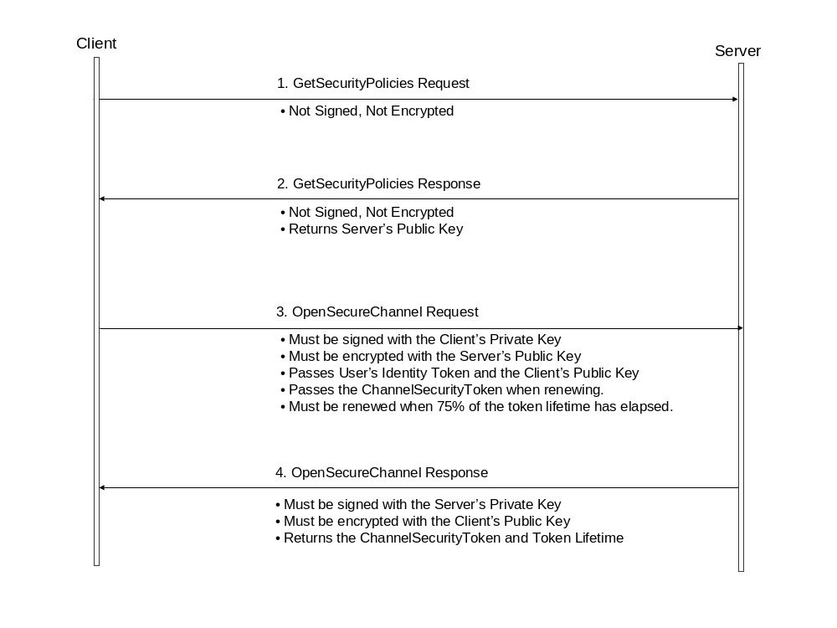
Figure 3 – Establishing a Secure Channel
Once the secure channel is established the messages are signed and encrypted with keys derived from the nonces exchanged in the OpenSecureChannel call. The algorithm for deriving keys is based on the P_SHA1 algorithm which defined in the [SSL/TLS] specification. The function is defined as followxs:
P_SHA1(secret, seed) = HMAC_SHA1(secret, A(1) + seed) +
HMAC_SHA1(secret, A(2) + seed) +
HMAC_SHA1 (secret, A(3) + seed) + ...
Where A(i) is defined axs:
A(0) = seed
A(i) = HMAC_SHA1(secret, A(i-1))
+ indicates that the results are appended to previous results.

The output of the P_SHA1 function is an infinite series of bytes. For convenience, the following function is used to select a specific set of bytes from the seriexs:
Byte[] P_SHA1(Byte[] secret, Byte[] seed, Int32 length, Int32 offset)
Where length is the number of bytes to select and offset is the position from the beginning of the series.
The keys used to secure messages are derived with the following formulaxs:
SharedSecret = P_SHA1(ClientNonce, ServerNonce, KeySize, 0)
ClientSigningKey = P_SHA1(SharedSecret, ClientNonce, KeySize, 0)
ClientEncryptionKey = P_SHA1(SharedSecret, ClientNonce, KeySize, KeySize)
ClientIntializationVector = P_SHA1(SharedSecret, ClientNonce, KeySize, 2*KeySize)
ServerSigningKey = P_SHA1(SharedSecret, ServerNonce, KeySize, 0)
ServerEncryptionKey = P_SHA1(SharedSecret, ServerNonce, KeySize, KeySize)
ServerIntializationVector = P_SHA1(SharedSecret, ClientNonce, KeySize, 2*KeySize)

Figure 4 illustrates how the various keys are derived and used when securing messages exchanged between UA applications.
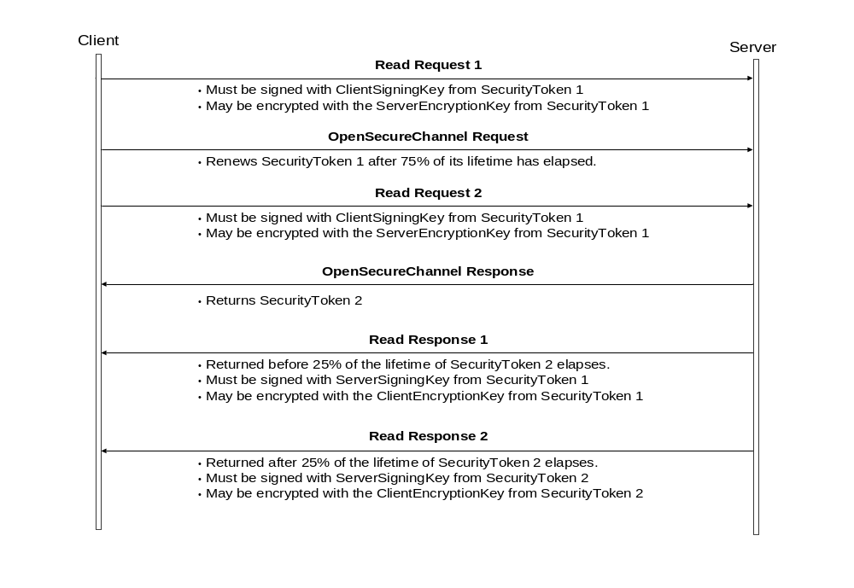
Figure 4 – Renewing Security Tokens

Applying Signatures
Most messages must be signed by the secure channel layer. How the signature is generated depends on the service being called and the security policies set by the server.
If the secure channel layer is sending GetSecurityPolicies request or response then the message is not signed.
If the secure channel layer is sending OpenSecureChannel request or response then the message must always be signed with the private key from application instance certificate for the sender. In this case, the SigningToken is the DER encoded form of the X509 certificate used to create the signature. The DER encoding is defined in [X690] specification.
The sender must choose a SignatureMethod that is appropriate for the X509 certificate being used. The server returns the SignatureMethods that it will accept as part of the BootstrapPolicies in the GetSecurityPolicies response. The server may choose to accept SignatureMethods which it did not explicitly claim to support, however, clients must be prepared for an error if they do not use one of the methods specified in the server’s BootstrapPolicies.
If the secure channel layer is sending any other message then there must be an active secure channel (i.e. OpenSecureChannel has been called at least once and CloseSecureChannel has not been called). The SignatureMethod is the same as specified in the SecurityPolicy selected in the OpenSecureChannel request. In this case, the SigningToken is a TokenId for the secure channel encoded as a null terminated UTF-8 string. Clause 5.4.3 of [UA Part 4] explains how to choose the correct TokenId for a secure channel.
Once the secure channel layer has calculated the signature it adds the signature to the SecurityFooter along with the size of the unencrypted message excluding the SecurityHeader and SecurityFooter.

Verifying Signatures
When a secure channel layer receives and decrypts a message it must read the SecurityHeader and then jump to the end of the message read the unencrypted message size. The receiver can now use the information in the SecurityHeader to recalculate the signature and compare it to the one provided in the SecurityFooter.
The receiver of a message must generate an error if the signature is not valid. If the message is signed with a security token for a secure channel then the receiver must reject the message if uses an SignatureMethod that does not match the algorithm specified in the SecurityPolicy that was selected when the OpenSecureChannel service was called.

Encryption
Most messages could be encrypted by the secure channel layer. The algorithm used to encrypt the messages depends on the message type and the active SecurityPolicy. The SecurityHeader is not encrypted, however the SecurityFooter is encrypted.
If the secure channel layer is sending a GetSecurityPolicies request or response then the message should not be encrypted.
If the secure channel layer is sending a OpenSecureChannel request or response then the message must be encrypted with the application instance certificate for the receiver. In this case, the EncryptingToken is the thumbprint of the X509 certificate. The thumbprint of a X509 certificate is the SHA-1 digest of the DER encoded form of the certificate.
The sender must choose a EncryptionMethod that is appropriate for the X509 certificate be used. The server returns the EncryptionMethods that it will accept as the BootstrapPolicies in the GetSecurityPolicies response. The server may choose to accept EncryptionMethods which it did not explicitly claim to support, however, clients must be prepared for an error if they do not use one of the methods specified in the server’s BootstrapPolicies
If the secure channel layer is sending any other message then there must be an active secure channel (i.e. OpenSecureChannel has been called at least once and CloseSecureChannel has not been called). The EncryptionMethod is the same as specified in the SecurityPolicy selected in the OpenSecureChannel request. In this case, the EncryptingToken the SigningToken is a TokenId for the secure channel encoded as a null terminated UTF-8 string. Clause 5.4.3 of [UA Part 4] explains how to choose the correct TokenId for a secure channel.
The signature must always be calculated before any encryption is applied and the signature bytes are encrypted as part of the security footer.

Decryption
A receiver reads the SecurityHeader to determine if encryption was applied to message and what algorithm was used. After the message is decrypted the last 4 bytes of the last block of plaintext contain the true size of the message (See description of SecurityFooter above). This size is used extract the SecurityFooter and verify signature.

Transport Layer

UA TCP Protocol

General
The UA TCP transport protocol manages a virtual connection between two applications that is automatically re-established if the underlying TCP socket is interrupted for some reason. In addition, the UA TCP protocol provides a way to break UA messages in smaller chunks and re-assemble them correctly.
The client is the application that establishes the initial connection. The server is the application that listens for new connections. The client must know in advance how to send a request for a new connection to the server. This is typically specified in the URL for a server endpoint that supports the UA TCP protocol.
For this reason, UA defines the URL scheme ‘opc.tcp’ which can be used to identify endpoints that support UA over TCP/IP. This scheme has a syntax which is identical to an http URL. The default port is 21897; however, this can be overridden in the URL itself. Examples of these URLs are:
opc.tcp://mycompany.com:1245/MyServer
opc.tcp://196.168.1.200/ServerX
The path portion of the URL is only for visual identification since only one application can use a single port. Future versions of this specification will define a mechanism to allow multiple applications to share a single port. In this case, the path will be used to direct results to the correct server application.
The UA TCP protocol defines several messages that may be exchanged between the client and server. These messages are summarized in Table 6 and is described in detail in the clauses that follow.
Table 6 – UA TCP Message Types
Message | Signature | Description
Hello | UATH | Establishes a new virtual connection with the server.  This message is only sent by the client.
Acknowledge | UATA | Acknowledges a new virtual connection.  This message is only sent by the server.
Disconnect | UATD | Gracefully closes a virtual connection.
Data | UAMG or UAMC | Transfers part of a UA service message.  The signature is 'UAMG' for the last piece of any UA message.
Abort | UAMA | Discards a partially transmitted UA message.
Error | UAME | Returns a error for a request

Platforms with limited memory may not be able to store an entire UA message in memory before sending it, as a result, they need to break the message into several chunks as send each chunk before continuing with message encoding. Receivers must be prepared to reassemble these chunks before processing the message.
When a sender breaks a UA message into multiple pieces it must send the entire UA message (or send an abort message) before starting the transmission of a new UA message. The receiver must abort the message immediately If the TCP/IP connect breaks. The sender must return a communication failure error for that particular message even If the connection is later re-established.
All messages headers are encoded using the UA Binary encoding.
The UA TCP transport may support communication over SSL/TLS instead of normal sockets.
Figure 5 illustrates the message sequence flow between a client and server during normal operation.
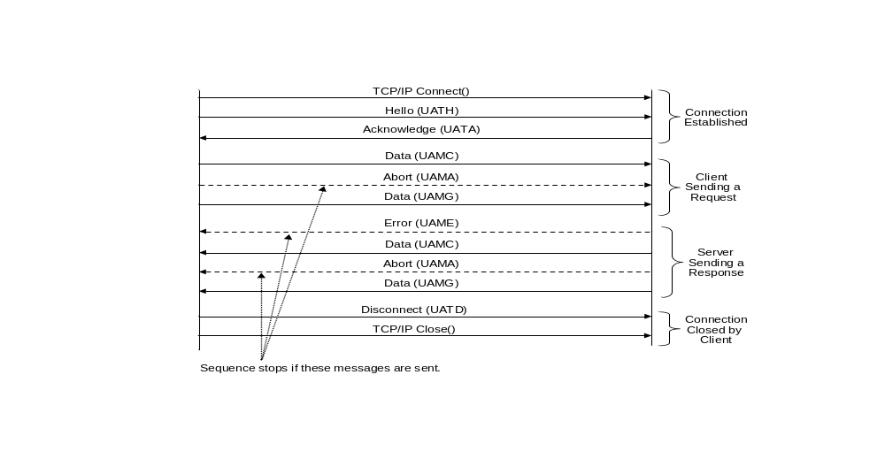
Figure 5 – UA TCP Normal Message Sequences

Hello
Once a TCP/IP connection has been established the client must send a hello message that includes the URL of the endpoint that it wishes to connect to plus a TCP/IP connection identifier (if re-establishing an interrupted connection). The hello message is described in Table 7.
Table 7 – UA TCP Hello Message
Field | Encoding | Comments
MessageType | Byte[4] | The signature of the hello message.  Must always be the ASCII string “UATH”
Length | UInt32 | The size of the message in bytes (including the MessageType and length).
Version | UInt32 | The version number of the used TCP message protocol. The server may reject the connection, if it does not support the requested protocol. If the server does not support the requested version then the server responds with an Error message.
ConnectionId | Guid | A unique identifier assigned by the server to a previous TCP/IP connection. This allows clients to re-establish connections that were interrupted for some reason. Clients should send a Null Guid if when establishing a connection for the first time.
Lifetime | UInt32 | The amount of time, in seconds, that the server should keep resources allocated for the connection alive for if the client unexpectedly disconnects. If the client specifies zero then the server should choose a suitable default value.
SendBufferLength | UInt32 | The size of the buffer, in bytes, that the client uses to send requests. The client will not send message fragments larger than this size. If the client specifies zero then the server should choose a suitable default value.
ReceiveBufferLength | UInt32 | The size of the buffer, in bytes, that the client uses to receive responses. The server should not send message fragments larger than this size. If the client specifies zero then the server should choose a suitable default value.
Endpoint | String | The URL of the endpoint that the client wishes to connect to.

Acknowledge
After sending the hello message the client must wait for an acknowledgement from the server before sending any more messages along the connection. The acknowledgement message is described in Table 8.
Table 8 – UA TCP Acknowledge Message
Field | Encoding | Comments
MessageType | Byte[4] | The signature of the acknowledgement message.  Must always be the ASCII string “UATA”
Length | UInt32 | The size of the message in bytes (including the MessageType and length).
ConnectionId | Guid | A unique identifier assigned by the server for the connection. If this value is a Null Guid then the server has rejected the connection and closed the socket. If the client specified a connection id in the hello message then the server must return the same id if it was possible to re-establish the same connection. If the connection could not be re-established the server should return a new connection identifier.
RevisedLifetime | UInt32 | The amount of time, in seconds, that the server will keep resources allocated for the connection alive for if the client unexpectedly disconnects. This value may be different from the time requested by the client.
RevisedSendBufferLength | UInt32 | The size of the buffer, in bytes, that the server uses to receive requests. If the requested size is non-zero, the value should be less or equal. If the client specified zero, the server should choose a suitable default value .
RevisedReceiveBufferLength | UInt32 | The maximum size of a message fragment, that will be sent by the server. This value should be equal or smaller than the requested value. If the client specified zero, the server should choose a suitable default value.  Returning 0 for means messages will not be fragmented by the server.
AlternateEndpoint | String | If the server rejects a connection it can specify an alternate URL that the client may use to re-attempt a connection.  This mechanism allows multiple applications to share a single port.

Once the connection has been established both the client and the server may send a UA service message at any time. In addition, the client may send multiple requests without waiting for a response and the server may respond to these requests in any order. However, once a client or server starts to send pieces of a message they must send all pieces of that message before sending any other message.

If the client closes the connection unexpectedly then the server must keep the any resources allocated for the connection active for the lifetime of the connection. Once the lifetime expires the server must assume the client has permanently gone and send an event to the higher layers.

If the server closes the connection unexpectedly then the client may periodically attempt to re-connect. If the client cannot reconnect within the connection lifetime then the client must assume the server is permanently gone and release all resources. Figure 6 illustrates the message sequence flow between a client and server when recovering from a network error. It is up to the client to decide how frequently it attempts to reconnect.
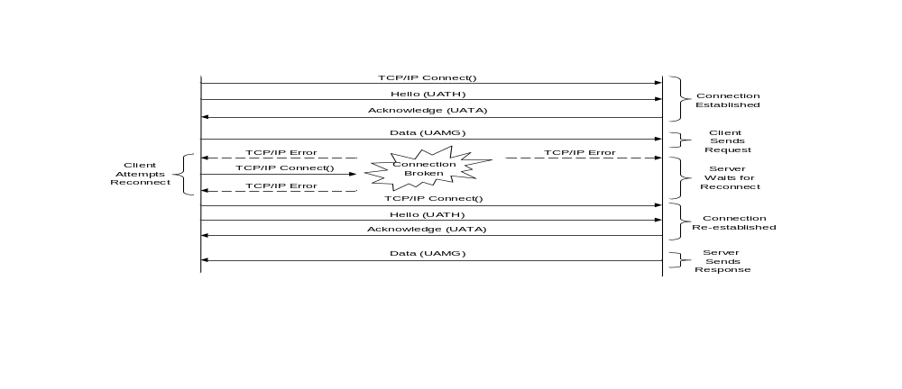
Figure 6 – UA TCP Error Recovery Sequences

Disconnect
If either the client or server wish to disconnect gracefully they must send a disconnect message before closing the socket. The disconnect message is described in Table 9.
Table 9 – UA TCP Disconnect Message
Field | Encoding | Comments
MessageType | Byte[4] | The signature of the disconnect message.  Must always be the ASCII string “UATD”
Length | UInt32 | The size of the message in bytes (including the MessageType and length).
ConnectionId | Guid | A unique identifier assigned by the server for the connection.

Data
If either the client or server wish to send all or part of a UA service message the must send a data message. The data message is described in Table 10.
Table 10 – UA TCP Data Message
Field | Encoding | Comments
MessageType | Byte[4] | The signature of the data message.  Must be the ASCII string “UAMG” if the message is complete.  Must be the ASCII string “UAMC” if there subsequent message.
Length | UInt32 | The size of the message in bytes (including the MessageType and length).
ConnectionId | Guid | A unique identifier assigned by the server for the connection.
RequestId | UInt32 | A unique identifier assigned by the client for the request that allows the client to match a response with a request. The server must return this value with the response.  A value of 0 is an invalid value and must not be used by the client.
MessageData | ByteString | The data in the message.

Abort
If the client or server wishes to discard a UA service message that has already been partially transmitted it must send an abort message. The abort message is described in Table 11.
Table 11 – UA Abort Message
Field | Encoding | Comments
MessageType | Byte[4] | The signature of the abort message.  Must always be the ASCII string “UAMA”
Length | UInt32 | The size of the message in bytes (including the MessageType and size).
ConnectionId | Guid | A unique identifier assigned by the server for the connection.
Request Id | UInt32 | A unique identifier assigned by the client for the request that allows the client to match a response with a request. The server must return this value with the response.

Error
If the server needs to return an error for a specific request then it must send an error message. The error message is described in Table 12.
Table 12 – UA Error Message
Field | Encoding | Comments
MessageType | Byte[4] | The signature of the error message.  Must always be the ASCII string “UAME”
Length | UInt32 | The size of the message in bytes (including the MessageType and size).
ConnectionId | Guid | A unique identifier assigned by the server for the connection.
Request Id | UInt32 | A unique identifier assigned by the client for the request that allows the client to match a response with a request. The server must return this value with the response.  This value is 0 if the error is not related to a specific request.
StatusCode | StatusCode | The numeric code for the error that occurred.

SOAP/HTTP
The UA Binary mapping also supports using SOAP/HTTP as a transport layer. In this scenario, the secured message is added to the SOAP body using the InvokeService XML syntax described in Clause 5.3.2.3.
In this scenario, none of other WS-* specifications are used. SOAP is simply a mechanism to move the bytes of the messages across a network. This approach may be used by applications that need to communicate through firewalls that only allow HTTP traffic.

XML Web Services Mapping

General
The XML web services mapping requires a communication stack that supports several web services specifications. The components required by UA are shown in Figure 7.
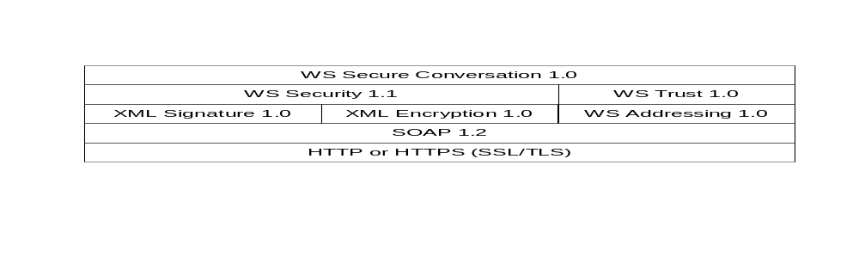
Figure 7 – The XML Web Services Stack
[HTTP] is the network communication protocol used to exchange SOAP messages. A UA service request message is always sent by the client in the body of an HTTP POST request. The server returns UA response message in the body of the HTTP response.
[HTTPS] is a variant of HTTP that encrypts and/or signs HTTP messages using the [SSL/TLS] protocol. HTTPS provides a efficient way to encrypt data sent across the network when two applications can communicate directly without intermediaries. However, HTTPS cannot meet the UA security requirements on its own: [WS Security] and [XML Signature] must always be used to sign the SOAP message bodies.
[WS Security] and [XML Encryption] may be used to encrypt SOAP messages instead of HTTPS.
[WS Addressing] specifies several SOAP standard headers which are used by SOAP intermediaries and stacks to route SOAP messages.
[WS Trust] and [WS Secure Conversation] provide a mechanism to establish secure channels as described in Clause 5.4 of [UA Part 4]. The exact relationship between these specifications and the UA secure channel services is discussed in Clause 5.3.5.
In addition to the specifications shown above, web service stacks must conform to [WS-I Basic Profile 1.1] and [WS-I Basic Security Profile 1.1]. These specifications ensure better interoperability between XML web service applications by clarifying or restricting the use of the various web service specificaions.
Many XML web service stacks support web services specifications that are not listed above (e.g. MTOM, WS-Reliable Messaging or WS-Profile). These specifications are not used by UA at this time, however, they may be incorporated in future versions of this document.

SOAP

General
SOAP describes an XML based syntax for exchanging messages between applications. UA messages are exchanged using SOAP by serializing the UA messages using one of the supported encodings described in Clause 6 and inserting that encoded message into the body of the SOAP message.
All UA messages are exchanged using the request-response message exchange pattern even if the UA service does not specify any output parameters. The server must return an empty response message that tells the client that no errors occurred.
UA does not define any SOAP headers, however, SOAP messages containing UA messages will include headers used by the other WS specifications in the stack.
All UA applications that support the XML web services mapping must support SOAP 1.2 as described in [SOAP Part 1].
SOAP faults are returned only for errors that occurred with in the SOAP stack. Errors that occur within the UA application are returned as UA error response messages as described in Clause 5.3 of [UA Part 4].
UA applications that support the XML Web Services mapping must support at least one of the UA message encoding formats. The mechanisms for inserting UA messages into SOAP messages are described in the clauses below. The SOAP action associated with each SOAP message indicates the encoding used in the message body.

XML Encoding
The UA XML Encoding specifies a way to represent a UA message as an XML element. This element is added to the SOAP message as the only child of the SOAP body element.
If an error occurs in the server while parsing the request body, the server may return a SOAP fault or it may return a UA error response.
The SOAP Action associated with an XML encoded request message always has the form:
http://opcfoundation.org/UA/<service name>
Where <service name> is the name of the UA service being invoked.
The SOAP Action associated with an XML encoded response message always has the form:
http://opcfoundation.org/UA/<service name>Response

UA Binary Encoding
The UA Binary Encoding specifies a way to represent a UA message as a sequence of bytes. These bytes sequences must be encoded in the SOAP body using the [Base64] data format.
The Base64 data format is a UTF-7 representation of binary data that is less efficient than raw binary data, however, many UA applications that exchange messages using SOAP will find that encoding UA messages in UA binary and then encoding the binary in Base64 is more efficient than encoding everything in XML.
The WSDL definition for a UA Binary encoded request message is:
<xs:element name="InvokeService" type="xs:base64Binary" nillable="true" />

<wsdl:message name="InvokeServiceMessage">
<wsdl:part name="InvokeService" element="tns:InvokeService" />
</wsdl:message>
The SOAP Action associated with a UA binary encoded request message always has the form:
http://opcfoundation.org/UA/InvokeService

The WSDL definition for a UA Binary encoded response message is:
<xs:element name="InvokeServiceResponse" type="xs:base64Binary" nillable="true" />

<wsdl:message name="InvokeServiceResponseMessage">
<wsdl:part name="InvokeServiceResponse" element="tns:InvokeServiceResponse" />
</wsdl:message>

The SOAP Action associated with a UA binary encoded response message always has the form:
http://opcfoundation.org/UA/InvokeServiceResponse

HTTP
HTTP defines a mechanism to exchange SOAP messages across a network. SOAP stacks used to implement the XML web service mapping must support the SOAP HTTP binding defined in [SOAP Part 2].
Some UA profiles defined in [UA Part 7] will require that transport layer security with HTTP over TLS as described in [HTTPS]

WS Addressing
[WS Addressing] defines standard headers used to route SOAP messages through intermediaries. SOAP stacks used to implement the XML Web Service mapping must support the WS-Addressing headers listed in Table 13.
Table 13 – WS-Addressing Headers
Header | Request | Response
To | Required | Required
From | Required | Required
ReplyTo | Required | Not Used
Action | Required | Required
MessageID | Required | Required
RelatesTo | Not Used | Required
Note that WS-Addressing defines standard URIs to use in the ReplyTo and From headers when a client does not have an externally accessible endpoint. In these cases, the SOAP response is always returned to the client using the same communication channel that sent the request.
UA servers must ignore the FaultTo header if it is specified in a request.

WS Security

General
[WS Security] defines headers used to describe how the components of SOAP messages are signed and/or encrypted. The mechanisms for actually signing XML elements are described in the [XML Signature] specification. The mechanisms for encrypting XML elements are described the [XML Encryption] specification.
[UA Part 4] defines a RequestHeader or a ResponseHeader parameter for each service message. These parameters include a field called the SecurityHeader which is not included in message bodies when UA applications use the XML web service mapping. Instead, it is implemented with the SOAP headers defined by the [WS Security] specification.

Signing Messages
A UA message may be signed with either a private key associated with a X509 certificate or with the a secret key derived from a [WS Secure Conversation] security context token.
If the message is signed with an X509 certificate then the WS-Security header must contain a X509 security token that conforms to the [X509 Security Token Profile]. The X509 security token should not assume that the receiver has prior knowledge of the certificate so the entire X509v3 certificate should be included in the token data.
If the message is signed with a secret key then the WS Security header must contain a DerivedKeyToken as described in the [WS Secure Conversation] specification. The algorithm used to derive the key is specified in each DerivedKeyToken, however, applications should use the algorithms defined in Clause 5.2.3.2.

Encrypting Messages
A UA message may be encrypted with either a public key associated with a X509 certificate or with a secret key derived from a [WS Secure Conversation] security context token. If a X509 certificate is used then the WS Security headers should include a X509 certificate token that identifies the certificate by either its thumbprint or subject. The entire X509 certificate should not be included in the token.
If the message is encrypted with a secret key then the WS Security header must contain a DerivedKeyToken as described in the [WS Secure Conversation] specification. The algorithm used to derive the key is specified in each DerivedKeyToken, however, applications should use the algorithms defined in Clause 5.2.3.2.

Timestamp
The [WS Security] specification uses the timestamp header to protect against replay attacks. UA applications may use this timestamp header, however, if it is present it should be signed with the same security token that was used to sign the message body.
The timestamp header is not mandatory because UA messages include a timestamp in the RequestHeader and ResponseHeader parameters.
The timestamp header should be present in the WS-Trust messages used to implement the OpenSecureChannel and CloseSecureChannel services.

WS Trust

General
[WS Trust] defines a mechanism to validate credentials and create security tokens that can be used as proof of possession of those credentials. [WS Trust] is used in the XML web services mapping in two ways. First, it provides a mechanism to translate user identity tokens owned by the UA client into something that the UA server will accept. Second, it provides the mechanism to issue and renew the security context tokens required by the [WS Secure Conversation] specification.

User Identity Tokens
Each UA server uses the GetSecurityPolicies service described in Clause 5.4.2 of [UA Part 4] to publish the types of user identity tokens that it supports. If a UA service accepts user tokens issued by a WS-Trust server then it must return a UserTokenPolicy structure that identifies the WS-Trust server and the type of tokens that the WS-Trust server issues. The contents of the UserTokenPolicy structure are described in Table 14.
Table 14 – WS-Trust User Token Policy
Parameter | Description
TokenType | The WS-Security Token URI
Issuer | The URL for the WS-Trust server.
IssuerType | Must always be “WS-Trust”

The security token returned from the WS-Trust server is an XML element with a syntax defined by the appropriate WS-Security token profile specification. The client must take the XML element and pass it to the CreateSession service as an instance of the WssSecurityToken type (see Clause 7.7.4 of [UA Part 4]).

Secure Channels
Most UA services can only be called after creating a secure communication channel. When UA applications implement the XML web services mapping, they must use [WS Trust] to request a security context token defined by the [WS Secure Conversation] specification to secure the message. The exact use of WS-Trust for this purpose is described in Clause 5.3.7.

WS Secure Conversation
[WS Secure Conversation] provides a mechanism to exchange shared secret keys that can be used to efficiently encrypt and sign multiple messages exchanged between web service applications over a period of time.
The tables in this section use a number of prefixes which have meanings defined in Table 15.
Table 15 – WS-* Namespace Prefixes
Prefix | Specification
wsu | WS-Security Utilities
wsse | WS-Security Extensions
wst | WS-Trust
wsc | WS-Secure Conversation
wsa | WS-Addressing
xenc | XML Encryption

[WS Secure Conversation] is used to implement the secure channel service set described in [UA Part 4]. In this mapping, a secure channel is created by requesting a security context token (SCT) from a WS-Trust server (called the SCT issuer) that supports the SCT binding. This SCT maps directly onto the ChannelSecurityToken parameter defined in [UA Part 4]. The exact relationship is described in Table 16.
Table 16 – ChannelSecurityToken to SCT Mapping
Parameter | Mapping
ChannelId | This value is the wsc:Identifier element of the SCT.
TokenId | This value is the wsc:Instance element of the SCT.
CreatedAt | This value is the wsu:Created time in the wst:Lifetime element returned by the SCT issuer.  If this value is not specified then the client uses the time that it receives the SCT.
RevisedLifetime | This value is calculated by subtracting the wsu:Created time from the wsu:Expires time in the wst:Lifetime element returned by the SCT issuer.  If the wst:Lifetime is not specified then this value is 0 (i.e. the SCT never expires).

It is expected that SOAP stack will automatically handle the handshaking required to establish and renew security context token. However, the UA application must have access to the identifier for the SCT associated with each message and this identifier must not change for the duration of the UA application session.
A client creates or renews a SCT by sending a RequestSecurityToken (RST) message to the same endpoint that is used for all other UA services. The SOAP action associated with this message must be “http://schemas.xmlsoap.org/ws/2005/02/trust/RST/SCT”.
The RST message has the components described in Table 17
Table 17 – RequestSecurityToken Message Components
Name | Description
wst:RequestedSecurityToken | Specifies the new SCT or renewed SCT.
wst:RequestType | Must be “http://schemas.xmlsoap.org/ws/2005/02/trust/Issue” when creating a new SCT.  Must be “http://schemas.xmlsoap.org/ws/2005/02/trust/Renew” when renewing a SCT.
wst:Entropy | This contains the nonce specified by the server.  The nonce is specified with the wst:BinarySecret element.  The xenc:EncryptedData element is not used in UA because the message body must be encrypted with the public key from the server’s certificate.
wst:OnBehalfOf | Specifies the identity of the user associated with the security SCT.  This parameter is optional.  This value is a SecurityToken that is constructed from the UserIdentityToken.  A UserNameIdentityToken is mapped onto Username Security Token  A X509IdentityToken is mapped onto a X509 Security Token  A WSSIdentityToken is already a WS-Security compatible Security Token.
wst:KeySize | This is the SignatureKeyLength from the SecurityPolicy selected by the client.  This also specifies the length of the nonce.
wst:SignatureAlgorithm | This is the URI for SignatureMethod from the SecurityPolicy selected by the client.  The mapping between the UA algorithm id and the WS-* URI is shown in Table 18.
wst:EncryptionAlgorithm | This is the URI for EncryptionMethod from the SecurityPolicy selected by the client.  The mapping between the UA algorithm id and the WS-* URI is shown in Table 18.
wst:Lifetime | The requested lifetime for the SCT.

The body of the RST message must be signed with private key from the client’s application instance certificate. The body must also be encrypted with the public key from the server’s application instance certificate.
Clients are expected to choose one of the SecurityPolicies returned by the server’s GetSecurityPolicies service. The server must reject the request if cannot find a SecurityPolicy that matches the combination of SignatureKeyLength, SignatureMethod and EncryptionMethod.
Servers that support the XML web services mapping should not support multiple SecurityPolicies for the same combination of SignatureKeyLength, SignatureMethod and EncryptionMethod. The mappings between UA algorithm identifiers and the URIs specified in the RST are shown in Table 18.
Table 18 – Security Algorithm Mappings
UA Algorithm Id | Web Services Algorithm URI
HMAC-SHA1 | http://www.w3.org/2000/09/xmldsig#hmac-sha1
RSA-SHA1 | http://www.w3.org/2000/09/xmldsig#rsa-sha1
AES128-CBC | http://www.w3.org/2001/04/xmlenc#aes128-cbc
AES196-CBC | http://www.w3.org/2001/04/xmlenc#aes196-cbc
AES256-CBC | http://www.w3.org/2001/04/xmlenc#aes256-cbc
RSA-PKCS1 | http://www.w3.org/2001/04/xmlenc#rsa-1_5
RSA-OAEP | http://www.w3.org/2001/04/xmlenc#rsa-oaep-mgf1p

A server issues a SCT by returning a RequestSecurityTokenResponse (RSTR) message to the client that sent the RST message. The SOAP action associated with the RSTR message must be “http://schemas.xmlsoap.org/ws/2005/02/trust/RSTR/SCT”.
The RSTR message has the components described in Table 19.
Table 19 – RequestSecurityTokenResponse Message Components
Component | Description
wst:RequestedSecurityToken | Specifies the new SCT or renewed SCT.
wst:RequestType | Must be “http://schemas.xmlsoap.org/ws/2005/02/trust/Issue” when creating a new SCT.  Must be “http://schemas.xmlsoap.org/ws/2005/02/trust/Renew” when renewing a SCT.
wst:Entropy | This contains the nonce specified by the server.  The nonce is specified with the wst:BinarySecret element.  The xenc:EncryptedData element is not used in UA because the message body must be encrypted with the public key from the client’s certificate.
wst:RequestedProofToken | This contains a wst:ComputedKey element which specifies the algorithm used to compute the shared secret key from the nonces provided by the client and the server.  This value is always “http://schemas.xmlsoap.org/ws/2005/02/trust/CK/PSHA1”
wst:Lifetime | The revised lifetime for the SCT.

The body of the RSTR message must be signed with private key from the server’s application instance certificate. The body must also be encrypted with the public key from the client’s application instance certificate.

Message Encoding

Built-in Types
All UA message encodings are based on rules that are defined for a standard set of built-in types. These built-in types are used to construct structures, arrays and messages. The built-in types are described in Table 20.
Table 20 – Built-in Data Types
Name | Description
Null | An unspecified value.
Boolean | A two-state logical value (true or false).
SByte | An 8 bit signed integer value.
Byte | An 8 bit unsigned integer value.
Int16 | A 16 bit signed integer value.
UInt16 | A 16 bit unsigned integer value.
Int32 | A 32 bit signed integer value.
UInt32 | A 32 bit unsigned integer value.
Int64 | A 64 bit signed integer value.
UInt64 | A 64 bit unsigned integer value.
Float | An IEEE single precision (32 bit) floating point value.
Double | An IEEE double precision (64 bit) floating point value.
String | A sequence of Unicode characters.
DateTime | An instance in time.
Guid | A 16 byte value that can be used as a globally unique identifier.
ByteString | A sequence of bytes.
XmlElement | An XML element.
NodeId | An identifier for a node in the address space of a UA server.
ExpandedNodeId | A NodeId that allows the namespace URI to be specified instead of an index.
StatusCode | A numeric identifier for a error or condition that is associated with a value or an operation.
DiagnosticInfo | A structure that contains detailed error and diagnostic information associated with a StatusCode.
ExtensionObject | A structure that contains an application specific data type that may not be recognized by the receiver.
DataValue | A data value with an associated status code and timestamps.
Variant | A union of all of the types specified above.

UA Binary

General
The UA Binary Encoding is a data format developed to meet the performance needs of UA applications. This format is designed primarily for fast encoding and decoding, however, the size of the encoded data on the wire was also a consideration.
The UA binary encoding relies on several primitive data types with clearly defined encoding rules that can be sequentially written to or read from a binary stream. The set of primitive types and their encoding rules are described in more detail below.
A structure is encoded by sequentially writing the encoded form of the value of each field to the buffer. If a given field is also a structure then the values of its fields are written sequentially before writing the next field in the containing structure.
The UA binary encoding does not include any type or field name information because all UA applications are expected to have advance knowledge of the services and structures that they support. That said, the ExtensionObject type provides mechanism to embed data structures that the recipient may not understand in the UA binary stream.

Built-in Types

Null
The Null type has no encoding and may only be used within an instance of Variant.

Boolean
A Boolean value must be encoded as a single byte where a value of 0 (zero) is false and any non-zero value is true.
It is recommended that encoders use the value of 1 to indicate a true value; however, decoders cannot assume that this will always be the case.

Integer
All integer types must be encoded as little endian values where the least significant byte appears first in the stream.
The Figure 8 illustrates how the value 1,000,000,000 (Hex: 3B9ACA00) should be encoded as a 32 bit integer in the stream.

Figure 8 – Encoding Integers in a Binary Stream

Floating Point
All floating point values must be encoded with the appropriate [IEEE-754] binary representation which has three basic componentxs: the sign, the exponent, and the fraction. The bit ranges assigned to each component depend on the width of the type. Table 21 lists the bit ranges for the supported floating point types.
Table 21 – Supported Floating Point Types
Name | Width (bits) | Fraction | Exponent | Sign
Float | 32 | 0-22 | 23-30 | 31
Double | 64 | 0-51 | 52-62 | 63
In addition, the order of bytes in the stream is significant. All floating point values must be encoded with the least significant bye appearing first (i.e. little endian).
The Figure 9 illustrates how the value -6.5 (Hex: C0D00000) should be encoded as a Float.

Figure 9 – Encoding Floating Points in a Binary Stream

String
All String values are encoded as a sequence of UTF-8 characters with a null terminator and preceded by the length in bytes.
The length is encoded as Int32. A value of 0 is used to indicate a ‘null’ string.
Figure 10 illustrates how the string “水Boy” should be encoded in a byte stream.
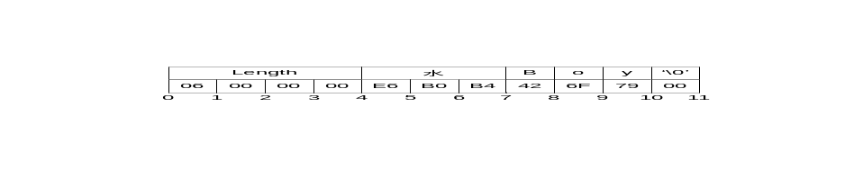
Figure 10 – Encoding Strings in a Binary Stream

DateTime
A DateTime value must be encoded as a 64-bit signed integer which represents the number of 100 nanosecond intervals since January 1, 1601. This is the same as the binary representation of the WIN32 FILETIME type.
Not all platforms will be able to represent the full range of dates and times that can be represented with this encoding. For example, the UNIX time_t structure only has a 1 second resolution and cannot represent dates prior to 1970. For this reason, a number of rules must be applied when dealing with date/time values that exceed the dynamic range of a platform’s. These rules are:
- A date/time value is encoded as 0 if:
  - The value equal to or earlier than 1601-01-01 12:00AM
  - The value is the earliest date that can be represented with the platform’s encoding.
- A date/time is encoded as Int64.MaxValue if:
  - The value is equal to or greater than 9999-01-01 11:59:59PM
  - The value is the latest date that can be represented with the platform’s encoding
- A date/time is decoded as the earliest time that can be represented on the platform if:
  - The encoded value is 0
  - The encoded value represents a time earlier than the earliest time that can be represented with the platform’s encoding.
- A date/time is decoded as the latest time that can be represented on the platform if:
  - The encoded value is Int64.MaxValue
  - The encoded value represents a time later than the latest time that can be represented with the platform’s encoding.
These rules imply that the earliest and latest times that can be represented on a given platform are invalid date/time values and should be treated that way by applications.

Guid
A Guid is encoded as sequence of unsigned integers (1 UInt32 value, 2 UInt16 values, 8 Byte values). The integers must be encoded individually in order to ensure the correct byte order is used for each integer.

ByteString
A ByteString is encoded as sequence of bytes preceded by its length in bytes. The length is encoded as a 32-bit signed integer as described above.
If the length of the byte string is -1 then the byte string is ‘null’.

XmlElement
An XmlElement is an XML fragment serialized as UTF-8 string and then encoded as ByteString.

NodeId
The components of a NodeId are described the Table 22.
Table 22 – NodeId Components
Name | Type | Description
Namespace | UInt32 | The index for a namespace URI.  An index of 0 is used for UA defined NodeIds.  An index of 1 is the default namespace for the server and indicates that the identifier is unique within the server's address space.  This value must be 0 for Uri and Guid identifier types because these types do not allow a namespace to be specified.
Identifier Type | Enum | The format and data type of the identifier  The value may be one of the following:  NUMERIC - the value is an Int32;  STRING - the value is String;  URI - the value is String;  GUID - the value is a Guid;  OPAQUE - the value is a ByteString;  The namespace index must be 0 if identifier type is GUID or URI.
Value | * | The identifier for a node in the address space of a UA server.

The encoding of a NodeId varies according to the contents of the instance. For that reason the first byte of the encoded form indicates the format of the rest of the encoded NodeId. The possible encoding formats are show in Table 23. The tables that follow describe the structure of the each possible format (they exclude the byte which indicates the format).
Table 23 – NodeId Encoding Values
Name | Value | Description
Two Byte | 0x00 | A numeric value that fits into the two byte representation.
Four Byte | 0x01 | A numeric value that fits into the four byte representation.
Numeric | 0x02 | A numeric value that does not fit into the two or four byte representations.
String | 0x03 | A String value.
Uri | 0x04 | A URI value.
Guid | 0x05 | A Guid value.
ByteString | 0x06 | An opaque (ByteString) value.
NamespaceURI Flag | 0x80 | See discussion of ExpandedNodeId in Clause 6.2.2.11.

The Two Byte Node Id encoding has the structure shown in Table 24.
Table 24 – Two Byte NodeId Binary Encoding
Name | Data Type | Description
Identifier | Byte | The Namespace is the default UA namespace (i.e. 0).  The Identifier Type is ‘Numeric’.  The Identifier must be in the range 0 to 255.

The Four Byte Node Id encoding has the structure shown in Table 25.
Table 25 – Four Byte NodeId Binary Encoding
Name | Data Type | Description
Namespace | Byte | The Namespace must be in the range 0-255.
Identifier | UInt16 | The Identifier Type is ‘Numeric’.  The Identifier must be an integer in the range 0-65535.

The Uri NodeId encoding has the structure shown in Table 26.
Table 26 – Uri NodeId Binary Encoding
Name | Data Type | Description
Identifier | String | The Identifier Type is ‘Uri’.  The Identifier is a String.

The Guid NodeId encoding has the structure shown in Table 27.
Table 27 – Guid NodeId Binary Encoding
Name | Data Type | Description
Identifier | Guid | The Identifier Type is ‘Guid’.  The Identifier is a Guid.

The standard NodeId encoding has the structure shown in Table 28. The standard encoding is used for all formats that do not have an explicit format defined.
Table 28 – Standard NodeId Binary Encoding
Name | Data Type | Description
Namespace | UInt32 | The Namespace index.
Identifier | * | The identifier which is encoded according to the following rulexs:
  NUMERIC | Int32
  STRING | String
  OPAQUE | ByteString

ExpandedNodeId
An ExpandedNodeId extends the NodeId structure by explicitly specifying the namespace URI instead of using the namespace index. Any given instance of a ExpandedNodeId may specify either the namespace index or the namespace URI. If both are specified by mistake then the encoder/decoder should ignore the namespace index.
The ExpandedNodeId is encoded by first encoding a NodeId as described in Clause 6.2.2.10 and then encoding namespace URI as a String.
An instance of an ExpandedNodeId may still use the namespace index instead of the namespace URI. In this case, the namespace URI is not encoded in the stream. The presence of the namespace URI in the stream is indicated by setting the most significant bit of the encoding format byte for the NodeId.
If the namespace URI is present then encoder must encode the namespace index as 0 in the stream when the NodeId portion is encoded. The unused namespace index is included in the stream because it allows the encoder to reuse the functions used to encode/decode NodeIds.
During decoding, the decoder should ignore any non-zero value for the namespace index if the namespace URI is present.

StatusCode
A StatusCode is encoded as a UInt32.

DiagnosticInfo
A DiagnosticInfo structure contains a number of fields that could be missing. For that reason, the encoding uses a bit mask to indicate which fields are actually present in the encoded form.
Some of the fields are indexes in a string table which is returned in the response header. Only the index of the string in this table is encoded. An index of -1 indicates that there is no value for the string.
Table 29 – DiagnosticInfo Binary Encoding
Name | Data Type | Description
Encoding Mask | Byte | A bit mask that indicates which fields are present in the stream.  The mask has the following bitxs:
  0x01 | Symbolic Id
  0x02 | Namespace
  0x04 | LocalizedText
  0x08 | Additional Info
  0x10 | Inner StatusCode
  0x20 | Inner DiagnosticInfo
Symbolic Id | Int32 | A symbolic name for the status code.
Namespace | Int32 | A namespace that qualifies the symbolic id.
LocalizedText | Int32 | A human readable summary of the status code.
Additional Info | String | Detailed application specific diagnostic information.
Inner StatusCode | StatusCode | A status code provided by an underlying system.
Inner DiagnosticInfo | DiagnosticInfo | Diagnostic info associated with the inner status code.

ExtensionObject
An ExtensionObject is encoded as sequence of bytes prefixed by a identifier for its data type encoding and the number of bytes. The data type encoding is the NodeId of a data type encoding node in the address space. Clause 5.8 of [UA Part 3] completely describes how data type encoding node are used. That said, the data type encoding is simply a unique identifier that tells the decoder how to interpret the data in the ExtensionObject.
An ExtensionObject may be encoded by the application which means it is passed as a ByteString or an XmlElement to the encoder. In this case, encoder will be able to write the number of bytes in the object before it encodes the bytes. However, an ExtensionObject may know how to encode/decode itself which means the encoder cannot encode the number of bytes before it encodes the object. In this situation, the encoder calls the function to encode the ExtensionObject in the output stream and calculates the length by reading the position in the stream before and after the object body. If the stream supports seeking, the encoder should update the length in the stream. If seeking is not supported by the stream then the encoder should save the start and end position of the object in the MessageFooter appended to the end of the message when encoding is complete (see Clause 5.2.2).
When a decoder encounters an ExtensionObject it must check if it recognizes the data type encoding identifier. If it does then it can call the appropriate function to decode the object body. If the decoder does not recognize the type it must decode the object body as a stream of bytes. The decoder can either read the length of the body from the stream if it is available or skip to the end of the data and find the object in the table of contents. If the decoder cannot skip to the end of the data then it must generate a decoding error.
The serialized form of a ExtensionObject is shown in Table 30.
Table 30 – Extension Object Binary Encoding
Name | Data Type | Description
Encoding Mask |  | A bit mask that indicates which fields are present in the stream.  The mask has the following bitxs:
  0x01 | Type Id
  0x02 | Binary Body
  0x04 | Xml Body
Type Id | ExpandedNodeId | The id for the data type encoding node in the server's address space.  ExtensionObjects defined by the UA specification have a numeric node identifier assigned to them with a NamespaceIndex of 0.  This value is required whenever an ExtensionObject is used as a message parameter.  It may be omitted if the ExtensionObject is contained in a Variant structure.
Length | Int32 | The length of the object body.  If the length is not known then the it set to -1.
Body | * | The object body.  A sequence of bytes for a Binary Body  An XML element encoded as a UTF-8 string for an Xml Body

ExtensionObjects are used in two contextxs: as values contained in Variant structures or a parameters in UA messages. If the ExtensionObject is a value in a Variant then the application will likely need to manually encode/decode the ExtensionObject. In this case, the application may omit the Type Id because it knows the receiver knows what data type to expect (e.g. the receiver is reading the value of a Variable which specifies the Data Type Id in an attribute). When an ExtensionObject is a message parameter it must have the Type Id specified and is usually serialized automatically by the encoder.

Variant
An Variant is a union of the built in types.
The structure of an Variant is shown in Table 31.
Table 31 – Variant Binary Encoding
Name | Data Type | Description
Encoding Mask | Byte | The type of data encoded in the stream.  The most significant bit indicates that the Variant contains an array.  The lower 7 bits are the type identifier for a built in type.
Array Length | Int32 | The number of elements in the array.  This field is only present if the array bit is set in the encoding mask.
Value | * | The value encoded according to its data type.  If the array bit is set in the encoding mask then each element in the array is encoded sequentially. Since many types have variable length encoding each element must be decoded in order.  The value must not be an Variant but it could be an array of Variants.  Arrays of Byte or XmlElement values are not permitted.

The possible types that can be encoded in an Variant are shown in Table 32.
Table 32 – Variant Encoding Masks
Mask | Type
0 | Null
1 | Boolean
2 | SByte
3 | Byte
4 | Int16
5 | UInt16
6 | Int32
7 | UInt32
8 | Int64
9 | UInt64
10 | Float
11 | Double
12 | String
13 | DateTime
14 | Guid
15 | ByteString
16 | XmlElement
17 | NodeId
18 | ExpandedNodeId
20 | StatusCode
21 | DiagnosticInfo
22 | ExtensionObject
23 | Variant
24 | DataValue

DataValue
A DataValue is always preceded by a mask that indicates which fields are present in the stream.
The fields of a DataValue are described in Table 33.
Table 33 – Data Value Binary Encoding
Name | Type | Description
Encoding Mask | Byte | A bit mask that indicates which fields are present in the stream.  The mask has the following bitxs:
  0x01 | Value
  0x02 | StatusCode
  0x04 | Server Timestamp
  0x08 | Source Timestamp
Value | Variant | The value.  Not present if the value is Null.
Status | StatusCode | The status associated with the value.  Not present if the status 'Good'
Server Timestamp | DateTime | The server timestamp associated with the value.  Not present if the timestamp is DateTime.MinValue.
Source Timestamp | DateTime | The source timestamp associated with the value.  Not present if the timestamp is DateTime.MinValue.

Enumerations
Enumerations are encoded as Int32 values.

Arrays
Arrays are encoded as a sequence of elements preceded by the number of elements encoded as an Int32 value. If an array is 'null' then its length is encoded as -1. An array of zero length is different from an array that is 'null' so encoders and decoders must preserve this distinction.

Simple Types
There are a number of simple types defined in [UA Part 3], [UA Part 4] and [UA Part 5]. These types are mapped to built-in types as shown in Table 34.
Table 34 – Simple Type Mapping
Simple Type | Mapping
Date | DateTime
Time | DateTime
UtcTime | DateTime
Counter | UInt32
Index | UInt32
Duration | Int32
IntegerId | Int32
NumericRange | String

Structures
Structures are encoded as a sequence of fields in the order that they appear in the definition. The encoding for each field is determined by the data type for the field.
All fields specified in the complex type must be encoded.
Structures do not have a 'null' value. If an encoder written in programming language that allows structures to have null values then the encoder must create new an instance with default values for all fields and serialize that. Encoders must not generate an encoding error in this situation.
An example the following structure defined in with C# syntax:
class Type2
{
int A;
int B;
}

class Type1
{
int X;
Type2[] Y;
int Z;
}
An instance of Type1 which contains an array of two Type2 instances would be encoded as seven 32-bit integers. The encoded form of an instance of Type1 is shown in Table 35.
Table 35 – Sample UA Binary Encoded Structure
Field | Bytes | Value
Type ID | 4 | The identifier for Type1
Length | 4 | 28
X | 4 | The value of field ‘X’
Y Length | 4 | 2
Y.A | 4 | The value of field ‘Y[0].A’
Y.B | 4 | The value of field ‘Y[0].B’
Y.A | 4 | The value of field ‘Y[1].A’
Y.B | 4 | The value of field ‘Y[1].B’
Z | 4 | The value of field ‘Z’

Messages
Messages are encoded as ExtensionObjects. The parameters in each message are serialized in the same way the fields of a structure are serialized.
Each UA service described in [UA Part 4] has a request and response message. The data type id for the request message is always an even number. The data type id for the response message is an odd number one more than the request. The data type ids assigned to each service are in Annex A.1.
Messages may contain ExtensionObjects that do not have a pre-calculated size when messages are serialized into a stream that does not support seeking. The MessageFooter with the positions of these ExtensionObjects must be appended to the message. See Clause 5.2.2 for more information.

XML

Built-in Types

General
Most built-in types are encoded in XML using the formats defined in [XML Schema Part 2] specification. Any special restrictions or usages are discussed below.
The prefix xs: is used to denote a symbol defined by the XML Schema specification.

Null
A Null is represented by an empty element or with the xs:nil attribute set to “true”.

Boolean
A Boolean value is encoded as an xs:boolean value.

Integer
Integer values are encoded using one of the sub types of the xs:decimal type. The mappings between the UA integer types and XML schema datatypes are shown in Table 36.
Table 36 – XML Datatype Mappings for Integers
Name | XML Type
SByte | xs:byte
Byte | xs:unsignedByte
Int16 | xs:short
UInt16 | xs:unsignedShort
Int32 | xs:int
UInt32 | xs:unsignedInt
Int16 | xs:long
UInt64 | xs:unsignedLong

Floating Point
Floating point values are encoded using one of the XML floating point types. The mappings between the UA floating point types and XML schema datatypes are shown in Table 37.
Table 37 – XML Datatype Mappings for Floating Points
Name | XML Type
Float | xs:float
Double | xs:double

String
A String value is encoded as an xs:string value.

DateTime
A DateTime value is encoded as an xs:dateTime value.
All DateTime values must be encoded as UTC times or with the time zone explicitly specified.
Correct:
2002-10-10T00:00:00+05:00
2002-10-09T19:00:00Z
Incorrect:
2002-10-09T19:00:00
It is recommended that all xs:dateTime values be represented in UTC format.
The earliest and latest date/time values that can be represented on a platform have special meaning and must be not be literally encoded in XML.
The earliest date/time value on a platform must be encoded in XML as '0001-01-01T00:00:00Z'.
The latest date/time value on a platform must be encoded in XML as '9999-12-31T11:59:59Z'
If a decoder encounters a xs:dateTime value that cannot be represented on the platform should convert the value to either the earliest or latest date/time that can be represented on the platform. The XML decoder should not generate an error if it encounters an out of range date value.
The earliest date/time value on a platform is equivalent to a 'null' date/time value.

Guid
A Guid is encoded as an xs:string with the format:
123456789-1234-1234-0102-030405060708
The string is created by formatting each of the Guid components as hexadecimal numbers.
Table 38 – String Format for Guid Components
Component | Data Type
Data1 | UInt32
Data2 | UInt16
Data3 | UInt16
Data4 | Byte[8]

The following string illustrates where the Guid components appear in the string:
<Data1>-<Data2>-<Data3>-<Data4[0:1]>-<Data4[2:8]>
All leading zeros must be included in the strings.
The XML schema for a Guid is:
<xs:complexType name="Guid">
<xs:sequence>
<xs:element name="String" type="xs:string" minOccurs="0" nillable="true" />
</xs:sequence>
</xs:complexType>

ByteString
A ByteString value is encoded as an xs:base64Binary value.

XmlElement
An XmlElement value is encoded as a xs:complexType with the following XML schema:
<xs:complexType name="XmlElement">
<xs:sequence>
<xs:any minOccurs="0" maxOccurs="1" processContents="lax"/>
</xs:sequence>
</xs:complexType>

XmlElements may only be used inside Variant or ExtensionObject values.

NodeId
An NodeId value is encoded as a xs:string with URI syntax:
<scheme>:n=<index>:<type>=<value>
The elements of the syntax are described in Table 39.
Table 39 – Components of NodeId URI
Field | Type | Description
<scheme> | String | The URI schema. Must always be 'opcua'.  The scheme may be omitted in when a URI is used within an XML document.
<index> | UInt32 | The namespace index formatted as a base 10 number.  If the index is 0 then the entire 'n=0:' clause must be omitted.
<type> | Enum | A flag that specifies the identifier type.  The flag has the following valuexs:
  i | NUMERIC (Int32)
  s | STRING (String)
  u | URI (String)
  g | GUID (Guid)
  b | OPAQUE (ByteString)
<value> | * | The identifier encoded as string.  The identifier is formatted using the XML data type mapping for the identifier type.  Any character is permitted for the value. When the URI is encoded in an XML document the XML parser must escape characters that are not permitted in XML. These escape characters but be removed by the decoder.

Examples of NodeIdxs:

i=13
n=10:i=-1
n=10:s=Hello:World
u=http://opcfoundation.org/UA/1.0
g=09087e75-8e5e-499b-954f-f2a9603db28a
n=1:b=M/RbKBsRVkePCePcx24oRA==
The XML schema for a NodeId is:
<xs:complexType name="NodeId">
<xs:sequence>
<xs:element name="Identifier" type="xs:string"
minOccurs="0" nillable="true" />
</xs:sequence>
</xs:complexType>

ExpandedNodeId
An ExpandedNodeId value is encoded as a xs:complexType with the following XML schema:
<xs:complexType name="ExpandedNodeId">
<xs:complexContent mixed="false">
<xs:extension base="tns:NodeId">
<xs:sequence>
<xs:element name="NamespaceURI" type="xs:string"
minOccurs="0" maxOccurs="1" nillable="true" />
</xs:sequence>
</xs:extension>
</xs:complexContent>
</xs:complexType>

If the NamespaceUri is missing then the NodeId should not include the namespace index (i.e. the namespace index should be set to 0).

StatusCode
A StatusCode is formatted in an xs:string as an 8 digit hexadecimal number.
The XML schema for a StatusCode is:
<xs:complexType name="StatusCode">
<xs:sequence>
<xs:element name="Code" type="xs:string" minOccurs="0" nillable="true" />
</xs:sequence>
</xs:complexType>

DiagnosticInfo
An DiagnosticInfo value is encoded as a xs:complexType with the following XML schema:
<xs:complexType name="DiagnosticInfo">
<xs:sequence>
<xs:element name="SymbolicId" type="xs:int" minOccurs="0" />
<xs:element name="NamespaceURI" type="xs:int" minOccurs="0" />
<xs:element name="LocalizedText" type="xs:int" minOccurs="0/>
<xs:element name="AdditionalInfo" type="xs:string" minOccurs="0" />
<xs:element name="InnerStatusCode" type="tns:StatusCode" minOccurs="0" />
<xs:element name="InnerDiagnosticInfo" type="tns:DiagnosticInfo"
minOccurs="0" nillable="true" />
</xs:sequence>
</xs:complexType>

ExtensionObject
An ExtensionObject value is encoded as a xs:complexType with the following XML schema:
<xs:complexType name="ExtensionObject">
<xs:sequence>
<xs:element name="TypeId" type="tns:ExpandedNodeId" nillable="true" />
<xs:element name="Body" minOccurs="0" nillable="true">
<xs:complexType>
<xs:sequence>
<xs:any minOccurs="0" processContents="lax"/>
</xs:sequence>
</xs:complexType>
</xs:element>
</xs:sequence>
</xs:complexType>
The body of the ExtensionObject contains a single element which indicates how the body is encoded. If the element name is “Xml” then the body is encoded directly in the XML. If the element name is “ByteString” then the body is encoded as xs:base64Binary text. No other body encodings are permitted.
The TypeId is the identifier for the DataTypeEncoding node.

Variant
An Variant value is encoded as a xs:complexType with the following XML schema:
<xs:complexType name="Variant">
<xs:sequence>
<xs:element name="Value" minOccurs="0" nillable="true">
<xs:complexType>
<xs:sequence>
<xs:any minOccurs="0" processContents="lax"/>
</xs:sequence>
</xs:complexType>
</xs:element>
</xs:sequence>
</xs:complexType>

If the Variant represents a scalar value then it must contain a single child element with the name of the built-in type. For example, the single precision floating point value 3.1415 would be encoded axs:

<Float>3.1415</Float>

If the Variant represents an array then it must contain a single child element with the prefix 'ListOf' and the name built-in type. For example an array of strings would be encoded axs:

<ListOfString>
<String>Hello</String>
<String>World</String>
</ListOfString>

The complete set of built-in type names is found in Table 20.
Variants may not contain an instance of an Variant, however, Variants may contain an array of Variants.

DataValue
A DataValue value is encoded as a xs:complexType with the following XML schema:
<xs:complexType name="DataValue">
<xs:sequence>
<xs:element name="Value" type="tns:Variant" minOccurs="0" nillable="true" />
<xs:element name="StatusCode" type="tns:StatusCode" minOccurs="0" />
<xs:element name="SourceTimestamp" type="xs:dateTime" minOccurs="0" />
<xs:element name="ServerTimestamp" type="xs:dateTime" minOccurs="0" />
</xs:sequence>
</xs:complexType>

Enumerations
Enumerations are encoded as xs:string with the following syntax:
<symbol>_<value>
The elements of the syntax are described in Table 40.
Table 40 – Components of Enumeration
Field | Type | Description
<symbol> | String | The symbolic name for the enumerated value.
<value> | UInt32 | The numeric value associated with enumerated value.

For example, the XML schema for the SecurityRequirement enumeration is:
<xs:simpleType name="SecurityRequirement">
<xs:restriction base="xs:string">
<xs:enumeration value="None_0" />
<xs:enumeration value="Header_1" />
<xs:enumeration value="Update_2" />
<xs:enumeration value="All_3" />
</xs:restriction>
</xs:simpleType>

Arrays
Arrays parameters are always encoded by wrapping the elements in a container element and inserting the container into the structure. The name of the container element should be the name of the parameter. The name of the element in the array must the type name.
For example, the Read service takes an array of ReadValueIds. The XML schema would look like:
<xs:complexType name="ListOfReadValueId">
<xs:sequence>
<xs:element name="ReadValueId" type="tns:ReadValueId"
minOccurs="0" maxOccurs="unbounded" nillable="true" />
</xs:sequence>
</xs:complexType>
The nillable attribute must be specified because XML encoders will drop elements in arrays if those elements are empty.

Structures
Structures are encoded as a xs:complexType with all of the fields appearing in a sequence. All fields are encoded as an xs:element and have xs:minOccurs and xs:maxOccurs set to 1.
For example, the Read service has a ReadValueId structure in the request. The XML schema would look like:
<xs:complexType name="ReadValueId">
<xs:sequence>
<xs:element name="NodeId" type="tns:NodeId" />
<xs:element name="AttributeId" type="xs:int" />
<xs:element name="IndexRange" type="xs:string" />
<xs:element name="DataEncoding" type="tns:DataEncoding" />
</xs:sequence>
</xs:complexType>

Messages
Messages are encoded as an xs:complexType. The parameters in each message are serialized in the same way the fields of a structure are serialized.

Formal Interface Definition

General
The UA specification is abstract specification that needs to be formally specified in a from that can be used by application developers.

Mapping File
The interface definition are created from the abstract specification by following a mechanical process. The same process is also used to create the software that implements the UA message encoding formats as well as programmers’ APIs for different development environments. This mapping is done with a code generator developed by the OPC Foundation.
The input to the code generator is a mapping file which is an XML document that formally describes all of the services and structures defined in [UA Part 4] and [UA Part 5]. The syntax of the mapping file is described in Annex D.
The mapping file is not a normative document and is not published with the specification. It exists to automate the process of producing the APIs in different programming environments. The APIs are also not normative. The formal interface definitions are the normative document which implementers must use.

UA Native Mapping
The formal interface definition for the UA Native mapping is an OPC Binary Type Dictionary. This file defines the structure of all types and messages. The syntax for an OPC Binary Type Dictionary is described in Appendix B of [UA Part 3]. This dictionary captures normative names for types and their fields as well the order the fields appear when encoded. The data type of each field is also captured.
The UA native mapping type dictionary is attached in Annex B.

XML Web Service Mapping
The formal interface definition for the XML web service mapping is a WSDL. This WSDL defines all types and messages required to implement the UA services. It also defines the a standard port type for all UA services.
The WSDL include bindings and service elements to ensure standard WSDL tools can process the WSDL, however, these elements should be replaced by values appropriate for each server implementation.
The UA XML web service mapping WSDL file is attached in Annex C.

Managing Certificates

Certificate Stores
UA applications make use of X509 certificates to implement the various security features. All systems with UA applications must have a certificate store that can be used to manage these certificates. A single machine may have multiple stores that are identified by a path (i.e. the StoreLocation) and name (i.e. the StoreName). Common store locations are described in Table 41.
Table 41 – Certificate Store Locations
Logical Name | Description
Current User | A store location for certificates visible only to the currently logged in user.
Local Machine | A store location for certificates visible to all users on a machine.

Each certificate in a store may have additional access privileges attached to it so even if a store is visible to a user, the user may not be able to use every certificate in the store.
All application instance certificates for UA applications must be placed in a store with the name 'UA Applications'. This store may be in any store location, however, it is recommended that all UA applications use the 'Local Machine' location for UA application certificates.
Private keys associated with software certificates must not be placed in the certificate stores because certificate stores allow any administrator to access the keys. This means that vendors would lose control of their software certificates and run the risk that others will write applications that pretend to be theirs. See Clause 8.2.4 for more information on protecting software certificates.

Application Instance Certificates

Installation
All UA applications must have an application instance certificate. This certificate is an X509 certificate that is used by a single application installed on a single machine. Multiple instances of the same application running on the same machine would used the application instance certificate.
When an application is installed the install program must automatically generate a new certificate or prompt the user to provide one. If the installer automatically generates the certificate it must sign the certificate with the private key for the certificate.

Certificate Trust Lists
Each UA application can only connect to other UA applications that it trusts. This is done by building a certificate trust list (CTL) for each application. The CTL for an application must be protected in the same way the private key for the application instance certificate is protected.
The CTL for an application should also be stored in certificate store with its certificate.

Certificate Revocation Lists
An administrator for a machine may periodically download certificate revocation lists (CRLs) for one or more certification authorities (CA). These lists are stored in the certificate store with the CA certificate. UA applications must not connect to UA applications with revoked certificates.
CRLs may be downloaded automatically by a UA application. UA does not define a mechanism to do this.

Proof of Possession
When a UA application connects to another UA application it must prove possession of the application certificate. It does this by taking random data provided by the other UA application and appending it to the DER form of the application instance certificate. It then applies the SHA-1 algorithm to calculate a digest and then signs that digest with the private key associated with the certificate.
The resulting signature is passed as a ByteString to the other UA application.

Software Certificates

General
UA applications may have one or more software certificates which contain a variety of information about the application including what certification tests it has passed. These content of the certificates is described in [UA Part 4], however, that description does not specify the physical format of the certificates.
UA supports two formats for the SoftwareCertificate structure: XML and UA Binary. Certificates using the XML format must be convert to the UA Binary format before they can be verified. The syntax for the UA Binary format follows the rules defined in Clause 6.2. The syntax for the XML format follows the rules defined in Clause 6.3.
A software certificate is signed by taking the UA binary encoded version and calculating the digest using the SHA-1 algorithm. This digest is then signed with the private key of a certificate owned by the organization responsible for testing the software for compliance. In many cases, the OPC Foundation will be the organization responsible for signing the software certificates.
UA applications that need to verify software certificates need to ensure the public keys for the testing authorities are loaded into the certificate store and are accessible to the application.
The bytes of the SoftwareCertificate and the signature are stored together in a structure called a SignedSoftwareCertificate.

Verification
When a UA application receives a SignedSoftwareCertificate from another UA application it must verify that the certificate is valid.
There are two steps:
- Verify the issuer's signature in the SignedSoftwareCertificate.
- Verify the X509 certificate contained in the SoftwareCertificate.
If any of these steps fail the receiver should reject the software certificate.

Server Discovery

Overview
UA applications will be deployed in many different environments which will have different requirements for a discovery. For that reason, UA defines conventions for locating UA services with different discovery protocols.

WS-Inspection
[WS Inspection] is a simple XML file based discovery mechanism. Each machine that has UA servers installed should provide a WS-Inspection file at the URL:
http://<machine>/UA/Services.wsil

WS-Discovery

UDDI

- Constants
  - Service Type Ids
- Type Declarations for the UA Native Mapping
- WSDL for the UA XML Mapping
- Mapping File Syntax
  - General
The other parts of this specification describe the UA services and information model in abstract terms without any reference to a specific implementation technology. This approach reflects the belief that specific implementation technologies will come and go, however, the overall UA architecture does not need to change.
In order to support this implementation independence, the UA specification defines a way to formally describe its services and information model in a form that can be interpreted by a computer program. The UA Type Dictionary is an XML based syntax that is intended to be used for this purpose. The choice of XML syntax is due to the availability of tools and parsers on a wide range of platforms.
A UA Type Dictionary is not the same as an XML Schema because UA does not require all of the features of XML Schema. For example, an XML Schema makes a distinction between attributes and child elements which is a complexity that the UA Type Dictionary does not require. In addition, the UA Type Dictionary uses terms and built-in data types that are consistent with the UA specification. That said, the syntax of the UA Type Dictionary can be described by an XML Schema. More importantly, any UA Type Dictionary document can be unambiguously converted to an XML Schema document by using the XML encoding rules described later in this document.
All data types that are defined by UA services or the UA information model will have UA Type Dictionary description. This description can be then used in a variety of ways to automate tasks related to developing an UA application including:
- Creating classes or structures in multiple programming languages (C/C++, .NET, Java);
- Serializing instances of the data types with different encodings (Binary, XML);
- Creating interface contracts for services for different platforms (WSDL, Indigo);
The UA Type Dictionary can also be used to describe any vendor defined data type; however, the UA specification does not require this. Vendor defined data types may use UA Type Dictionaries, XML Schema or other type description system that may be appropriate for the data type.
  - Dictionary
A Dictionary is the root element of UA Type Dictionary document. It contains one or more simple types, complex types, enumerated types or services. A dictionary is used to group several related types that are managed together. All types defined in a dictionary must belong to the same namespace.
A dictionary is represented in the UA namespace by a data type dictionary node where the Node ID is constructed from the dictionary’s namespace and name attributes. The value of the document property of the dictionary node is an XML document containing the dictionary.
The XML Schema definition of a dictionary element is:
<xxs:element name="Dictionary">
<xxs:complexType>
<xxs:choice maxOccurs="unbounded">
<xxs:element name="SimpleType" type=" SimpleType"></xxs:element>
<xxs:element name="ComplexType" type="ComplexType"></xxs:element>
<xxs:element name="EnumeratedType" type="EnumeratedType"></xxs:element>
<xxs:element name="Service" type="Service"></xxs:element>
</xxs:choice>
<xxs:attribute name="Namespace" type="xxs:string"
use="required"></xxs:attribute>
</xxs:complexType>
</xxs:element>
The components of a dictionary are described in Table 42.
Table 42 – Dictionary Element Components
Name | Use | Description
Namespace | 1..1 | The URI of the namespace which provides the context for all types defined in the dictionary.
Simple Type | 0..n | The description of a simple data type.
Complex Type | 0..n | The description of a complex data type.
Enumerated Type | 0..n | The description of an enumerated type.
Service | 0..n | The description of a UA server type.
  - Abstract Type
An Abstract Type is the base class for all other types. It defines attributes that are common to all types.
The XML Schema definition of a abstract type element is:
<xxs:complexType name="AbstractType">
<xxs:attribute name="Name" type="xxs:string"
use="required"></xxs:attribute>
</xxs:complexType>
The components of a dictionary are described in Table 43.
Table 43 – Abstract Type Element Components
Name | Use | Description
Name | 1..1 | The name of the type. All types in a dictionary must have unique names.
  - Simple Type
A Simple Type allows other types (including built-in types) to be re-used with a different identifier. This allows special semantics to be associated with a type without changing underlying structure of the type. For example, a 64-bit integer that represents the number of 100 nanosecond intervals since 1601-01-01 could be defined to a Simple Type called ‘Gregorian Time’.
The XML Schema definition of a Simple Type element is:
<xxs:complexType name="SimpleType">
<xxs:complexContent>
<xxs:extension base="AbstractType">
<xxs:attribute name="BaseType" type="xxs:QName"
use="required"></xxs:attribute>
<xxs:attribute name="ArrayLength"
type="xxs:unsignedInt"></xxs:attribute>
</xxs:extension>
</xxs:complexContent>
</xxs:complexType>
The components of a simple type are described in Table 44.
Table 44 – Simple Type Components
Name | Use | Description
Base Type | 1..1 | The qualified name of the type that the simple type is derived from. This can be a built-in type, another type in the same dictionary or a type in another dictionary.
Array Length | 0..1 | The number of elements in an array. If specified then the simple type is an array of the base type. If this value is zero then the size of the array is set at runtime. Otherwise, the simple type is a fixed length array.
  - Complex Type
A Complex Type represents structured data that contains one or more named fields. A complex type can exist independently as part of a dictionary or can be part of another complex type. A complex type that is defined within another complex type is called a nested complex type.
A complex type may be derived from another complex type. In this case, an instance of the type consists of the fields in the base type appearing in sequence followed by the fields in the derived type. The names of the fields in the derived type may not be the same as names in the base type.
The XML Schema definition of a Complex Type element is:
<xxs:complexType name="ComplexType">
<xxs:complexContent>
<xxs:extension base="AbstractType">
<xxs:sequence>
<xxs:element name="Field" type="FieldType"
maxOccurs="unbounded"></xxs:element>
</xxs:sequence>
<xxs:attribute name="BaseType" type="xxs:QName"></xxs:attribute>
</xxs:extension>
</xxs:complexContent>
</xxs:complexType>
The components of a complex type are described in Table 45.
Table 45 – Complex Type Components
Name | Use | Description
Base Type | 1..1 | The qualified name of the type that the complex type is derived from. This can be another complex type in the same dictionary or a complex type in another dictionary.
The XML Schema definition of a Field Type element is:
<xxs:complexType name="FieldType">
<xxs:sequence>
<xxs:element name="ComplexType" type="ComplexType"
minOccurs="0"></xxs:element>
</xxs:sequence>
<xxs:attribute name="Name" type="xxs:string"
use="required"></xxs:attribute>
<xxs:attribute name="ArrayLength" type="xxs:unsignedInt"></xxs:attribute>
<xxs:attribute name="SingularName" type="xxs:string"></xxs:attribute>
<xxs:attribute name="IsAttribute" type="xxs:boolean"
default="false"></xxs:attribute>
<xxs:attribute name="DefaultValue" type="xxs:string"></xxs:attribute>
<xxs:attribute name="DataType" type="xxs:QName"></xxs:attribute>
</xxs:complexType>
The components of a field type element are described in Table 46.
Table 46 – Field Type Components
Name | Use | Description
Name | 0..1 | A name for the field that is unique within the scope of the dictionary.
Data Type | 0..1 | The qualified name of the data type contained in the field. This can be a built-in type, another type in the same dictionary or a type in another dictionary. This attribute must not be specified if a nested complex type is defined.
Complex Type | 0..1 | This is a complex type that describes the data contained in the field. This element must not be specified if the data type attribute is specified.
Singular Name | 0..1 | The singular spelling of the field name that can be used in the generated code.
Is Attribute | 0..1 | Whether the field should be mapped to an attribute in an XML schema.
Default Value | 0..1 | The default value for the field.
Array Length | 0..1 | The number of elements in an array. If specified then the simple type is an array of the base type. If this value is zero then the size of the array is set at runtime. Otherwise, the simple type is a fixed length array.
  - Enumerated Type
An enumerated type represents a simple type which has a finite set of named values. Each value for an enumerated type has a string and a numeric identifier.
The XML Schema definition of an enumerated type element is:
<xxs:complexType name="EnumeratedType">
<xxs:complexContent>
<xxs:extension base="AbstractType">
<xxs:sequence>
<xxs:element name="Value" maxOccurs="unbounded">
<xxs:complexType>
<xxs:simpleContent>
<xxs:extension base="xxs:string">
<xxs:attribute name="Index" type="xxs:int"></xxs:attribute>
</xxs:extension>
</xxs:simpleContent>
</xxs:complexType>
</xxs:element>
</xxs:sequence>
</xxs:extension>
</xxs:complexContent>
</xxs:complexType>
The components of an enumerated type are described in Table 47.
Table 47 – Enumerated Type Components
Name | Use | Description
Value | 1..n | A valid value for an instance of the type. Each value has numeric index associated with it. If the index is not explicitly specified in the type definition then a default index is one more than the previous value. If the first value has no index specified then it has a default index of zero.
Index | 0..1 | An integer value associated with the string. If not specified the enumerated value will have an integer value 1 more than the previous enumerated value. The first enumerated have has an index of 0 if it is not explicitly specified.
  - Service Type
A Service Type describes an operation which a client may ask a server to perform. Each service consists of a request message, a response message and a set of faults.
The XML Schema definition of a service type element is:
<xxs:complexType name="Service">
<xxs:complexType name="ServiceType">
<xxs:complexContent>
<xxs:extension base="AbstractType">
<xxs:sequence>
<xxs:element name="Request" minOccurs="0" maxOccurs="1">
<xxs:complexType>
<xxs:sequence minOccurs="0">
<xxs:element name="Parameter" type="FieldType"
maxOccurs="unbounded"></xxs:element>
</xxs:sequence>
</xxs:complexType>
</xxs:element>
<xxs:element name="Response" minOccurs="0" maxOccurs="1">
<xxs:complexType>
<xxs:sequence minOccurs="0">
<xxs:element name="Parameter" type="FieldType"
maxOccurs="unbounded"></xxs:element>
</xxs:sequence>
</xxs:complexType>
</xxs:element>
</xxs:sequence>
</xxs:extension>
</xxs:complexType>
</xxs:complexContent>
The components of a service type are described in Table 48.
Table 48 – Service Type Components
Name | Use | Description
Request | 0..1 | A sequence of named parameters that are passed by the client to the server. The request is used to initiate the service operation.
Response | 0..1 | A sequence of named parameters that are passed by the server back to the client after the service operation completes
Parameter | 0..1 | A named value that is part of either the request or the response for a service. The structure of the parameter is described by the field type element in Section D.5.

